Aug 5th 2008 A guided walk round the site of the deserted medieval village of
Wharram Percy.

The evening began with a picnic in the ruins of St Martin’s church which luckily afforded some protection from the inclement weather, typical of the poor English summer.

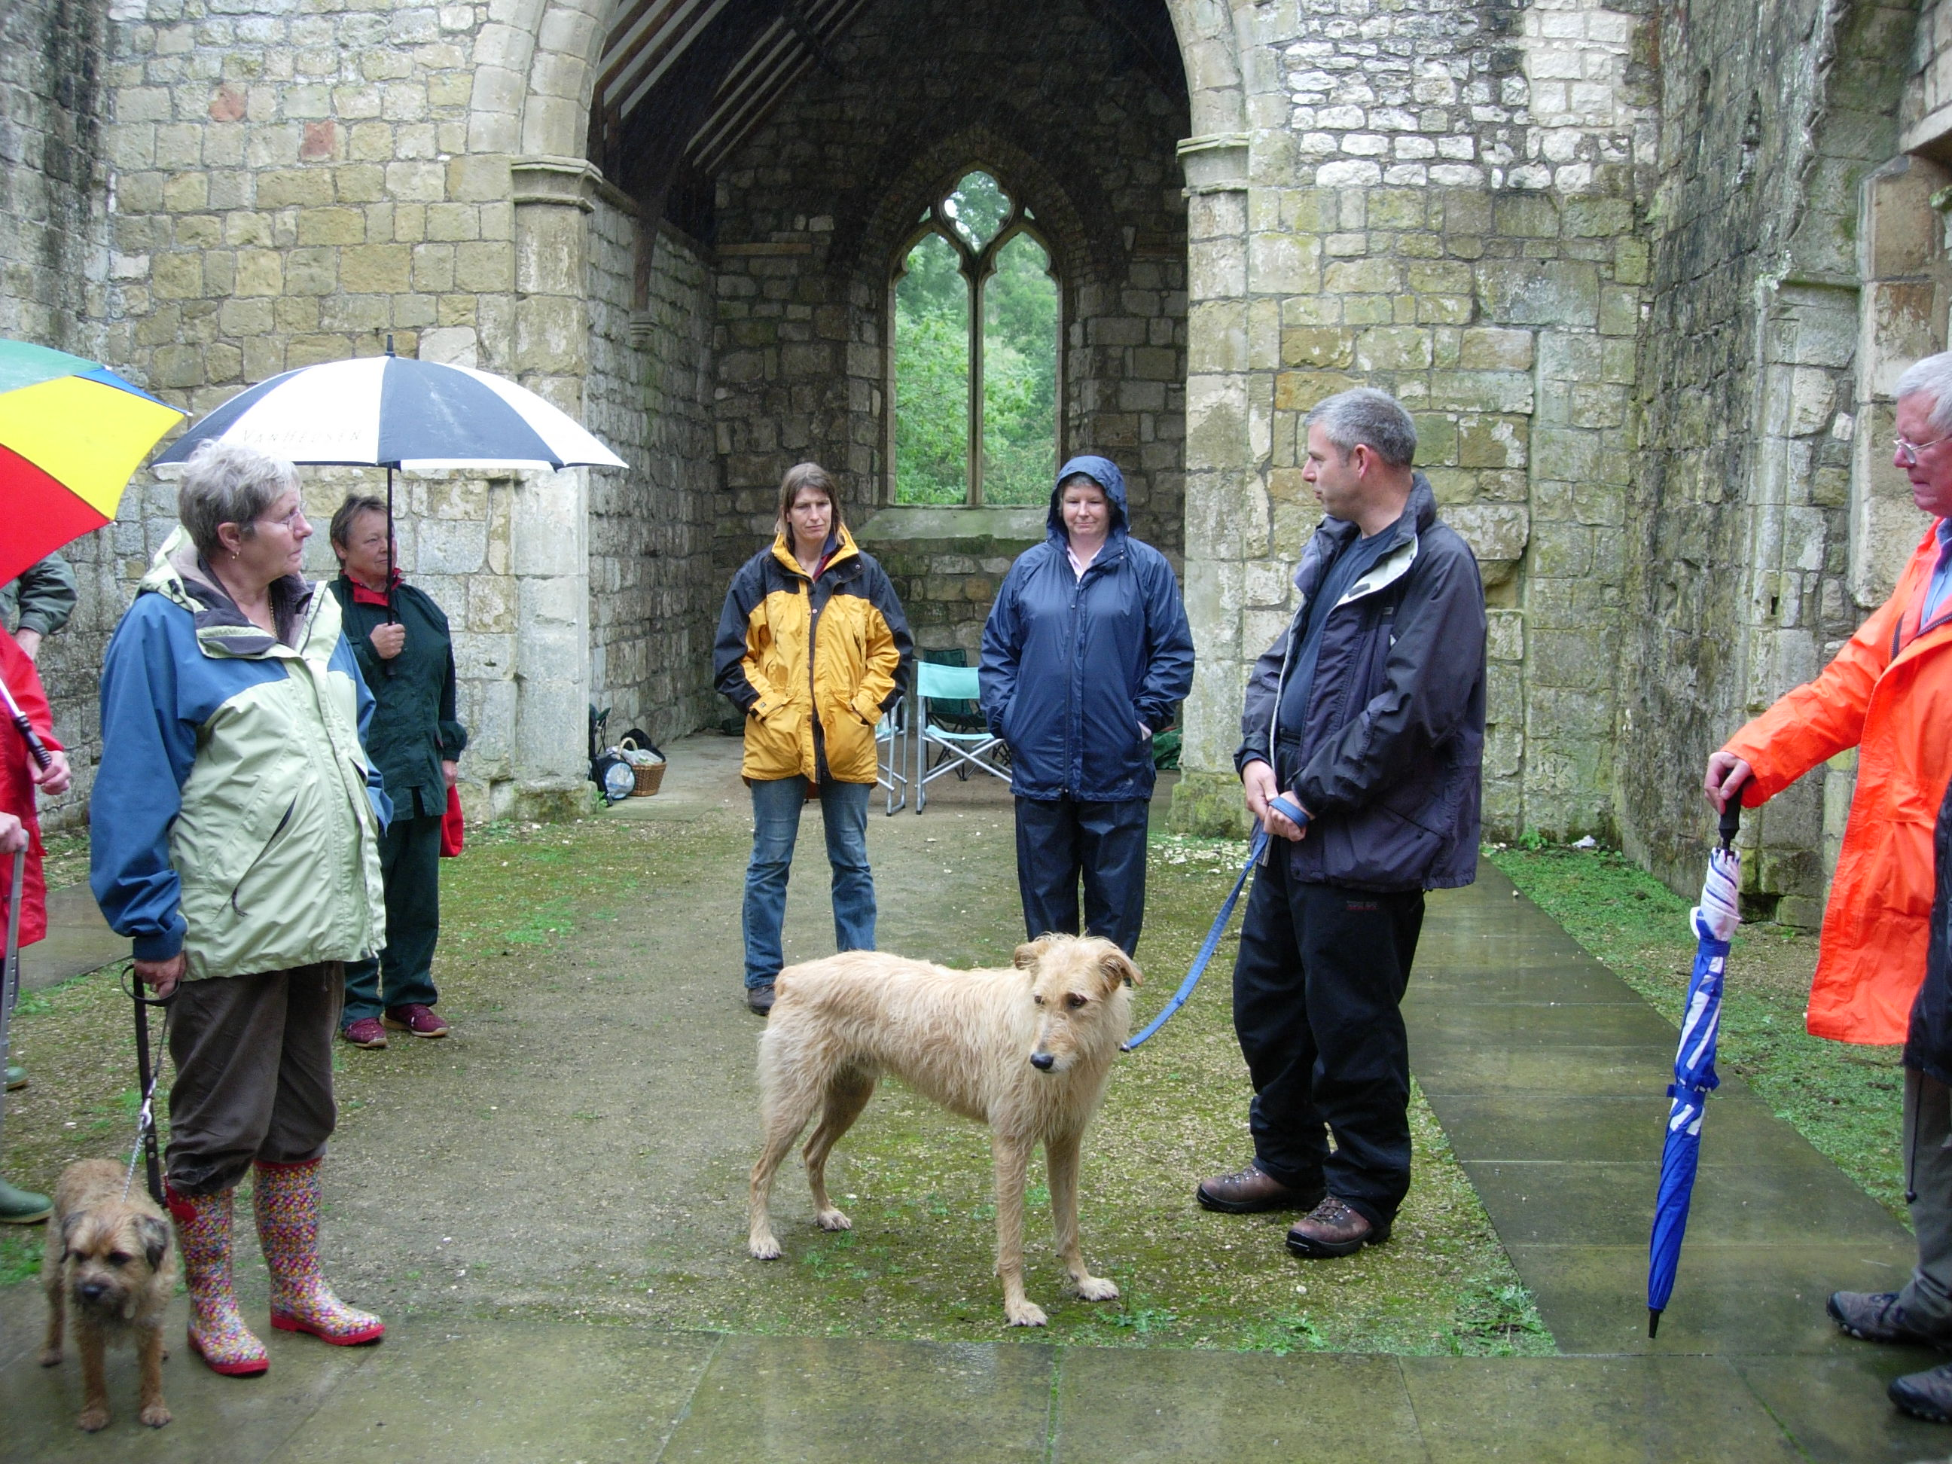
Alistair Oswald, a member of English Heritage’s Landscape Detectives team, began his talk here by pointing out some distinctive features of the ruins.
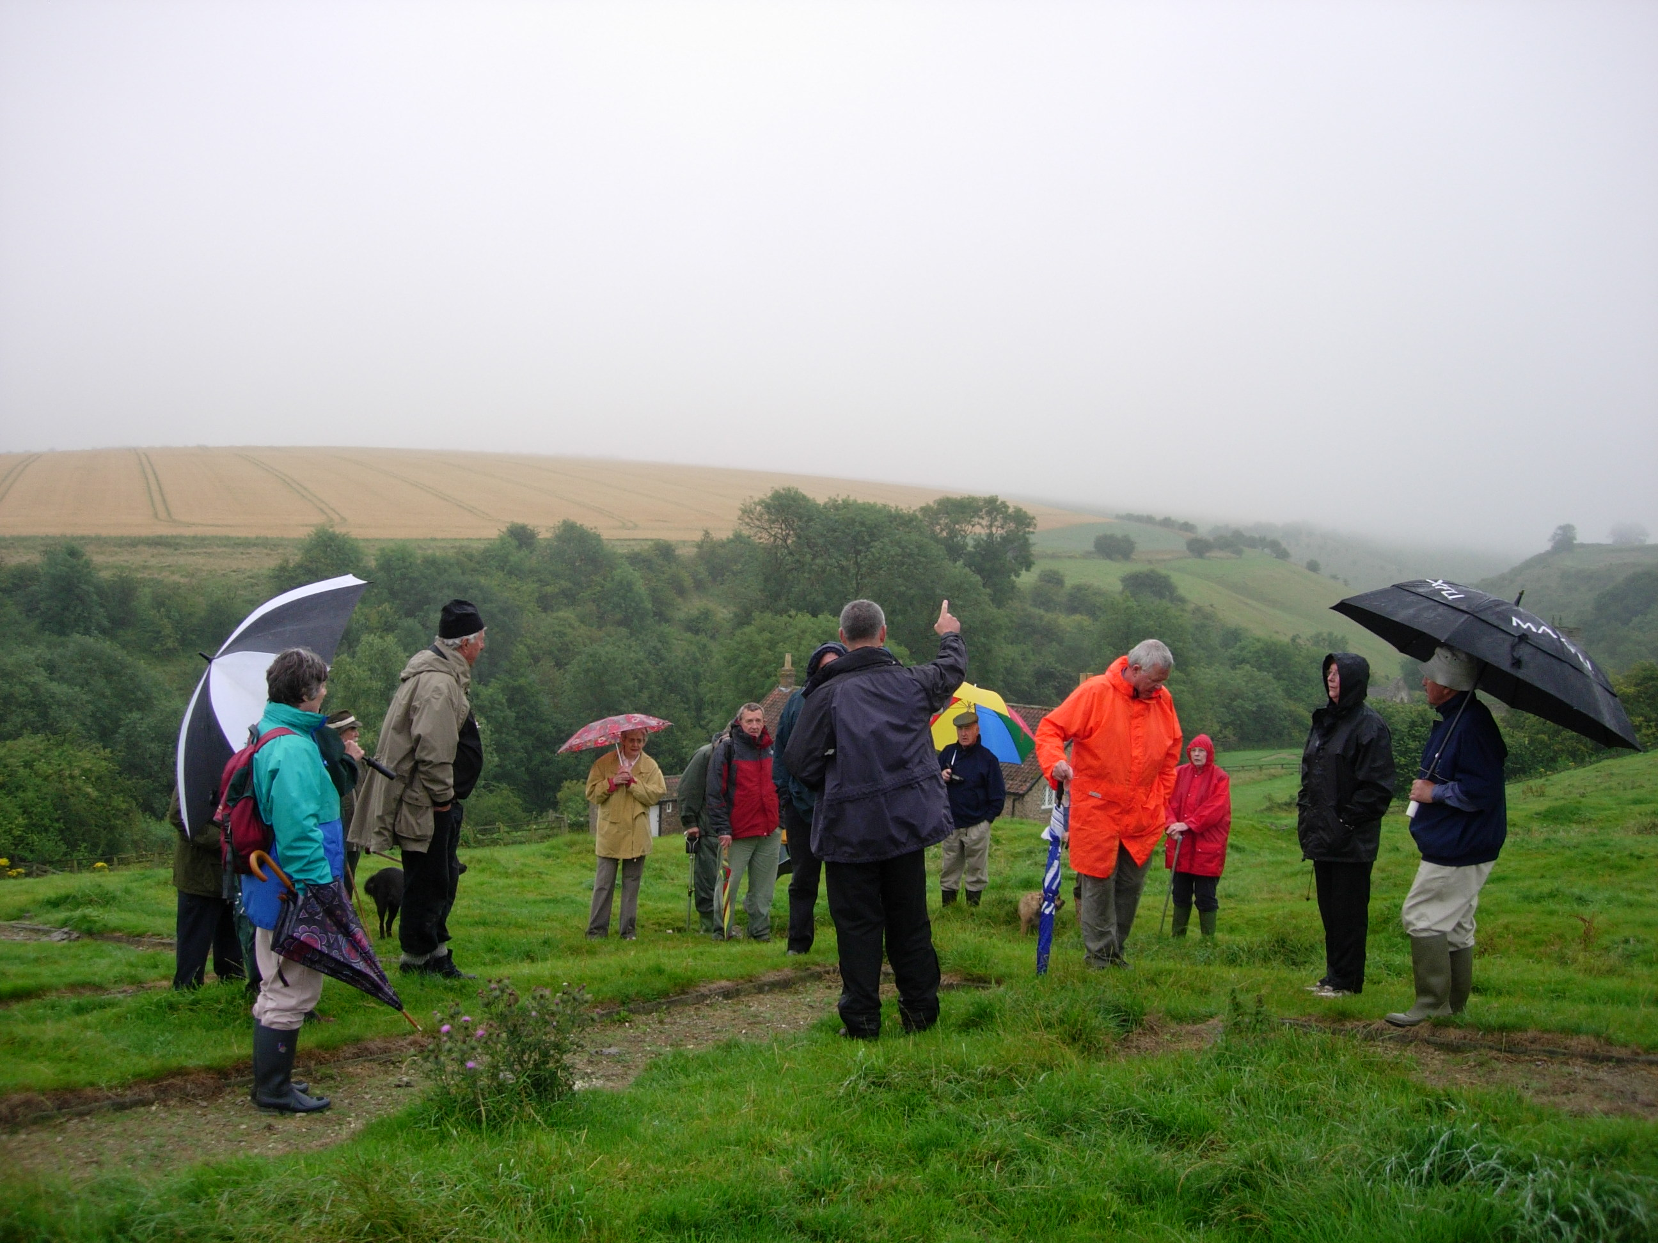
We then climbed the hillside to view the site of the deserted village where Alistair pointed out the layout of roads, houses and manors, explaining the different thinking of archaeologists.

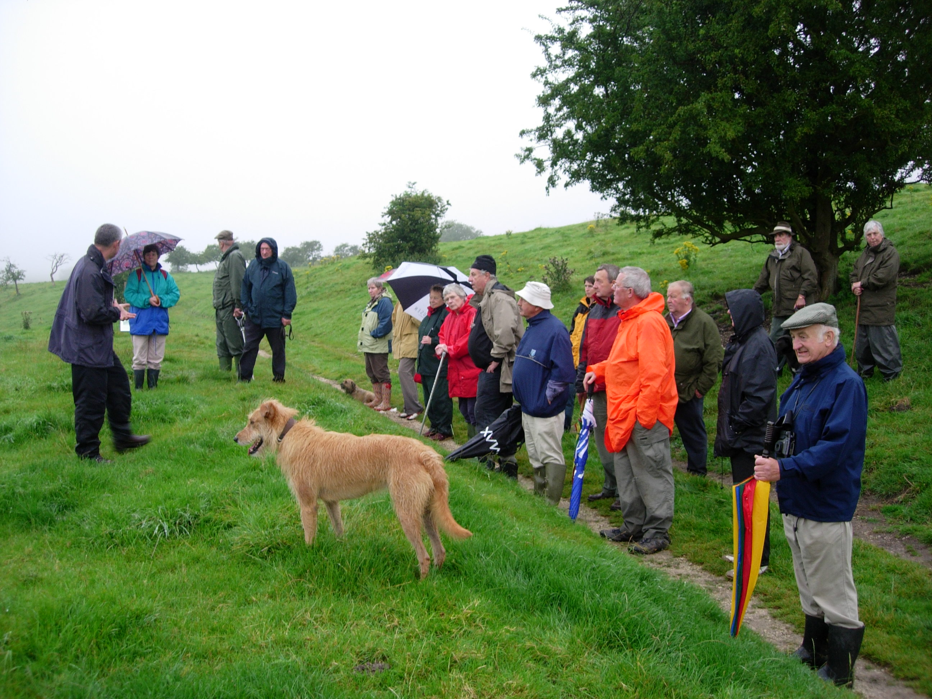
Despite the miserable weather, everyone enjoyed Alistair’s informative guided walk.
Although many of the HWHG members had visited the site on several occasions, many of the features pointed out by Alistair had not previously been observed, illustrating the value of the expert’s eye and knowledge.
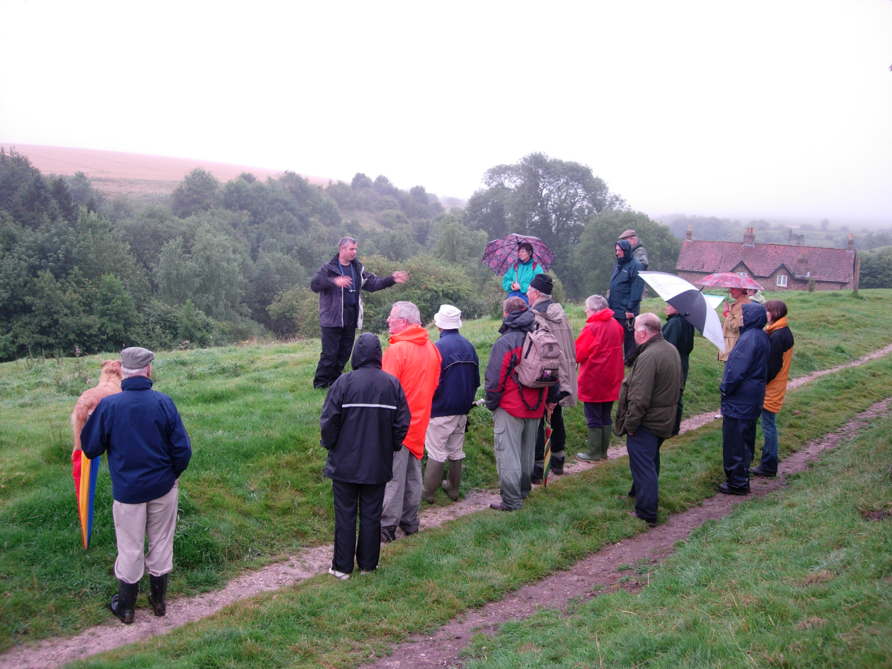
~ o ~



