October 2008 — BBC interviews were broadcast on the local TV programme
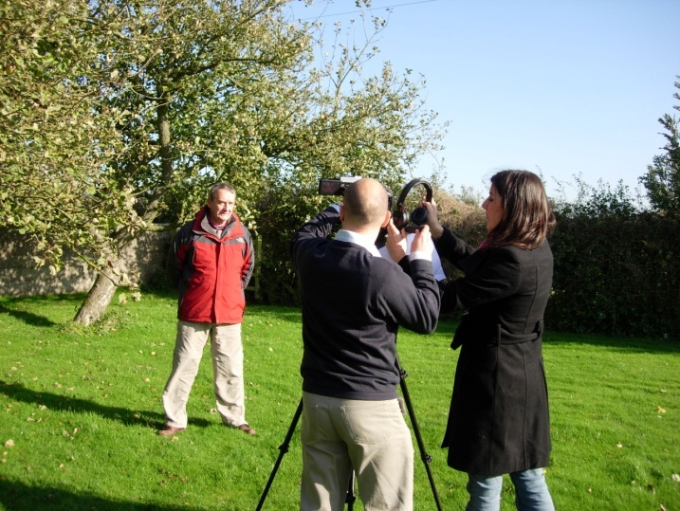
‘Look North’.

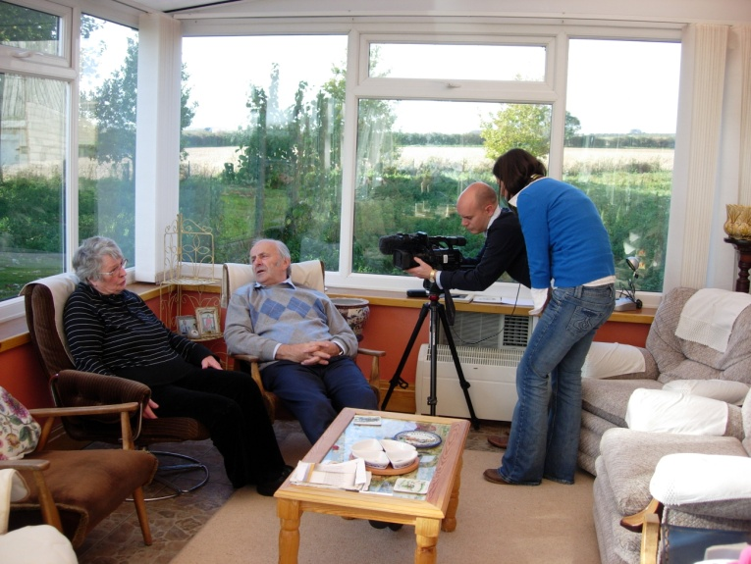
David Sharpe describes the aims of the High Wolds Heritage Group and acknowledges the HLF funding.

Ivy Eden and Chris Whitfield converse in the dialect of the Yorkshire Wolds.

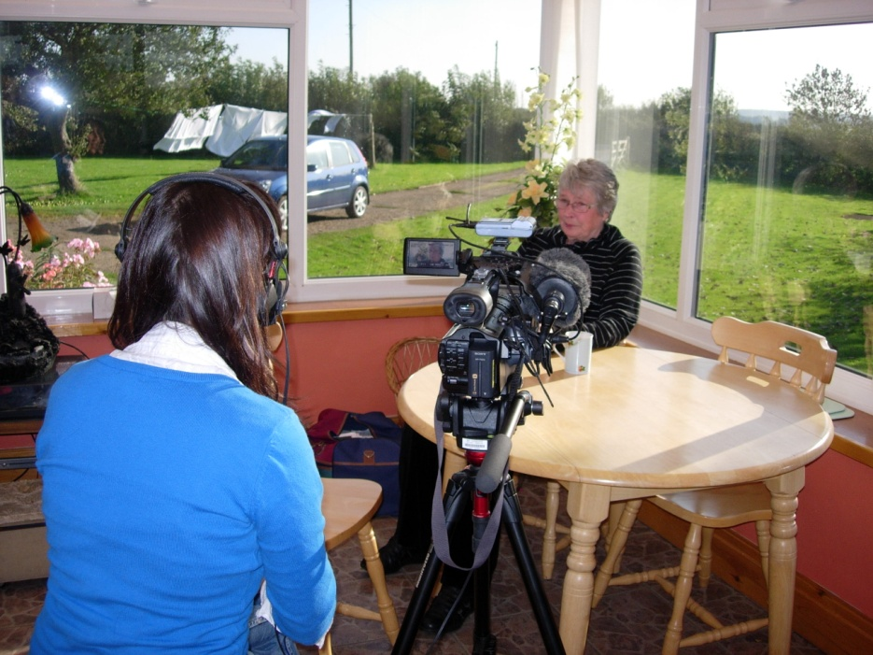

Ivy tells of her first days in York after leaving school.

