
Brian Eden’s Slide Show
“Thixendale in the 1960s”

This event launched the second year of the HWHG and was attended by 34 people and held on Thursday 30th October 2008 in Thixendale Village Hall.

Brian’s wife, Ivy, provided most of the commentary with short interjections from Brian. In her own inimitable way Ivy was most amusing with perceptive questions and comments usually related to the fashions and customs of that era. Some of the audience also featured in slides and added personal recollections of their younger days in the village.

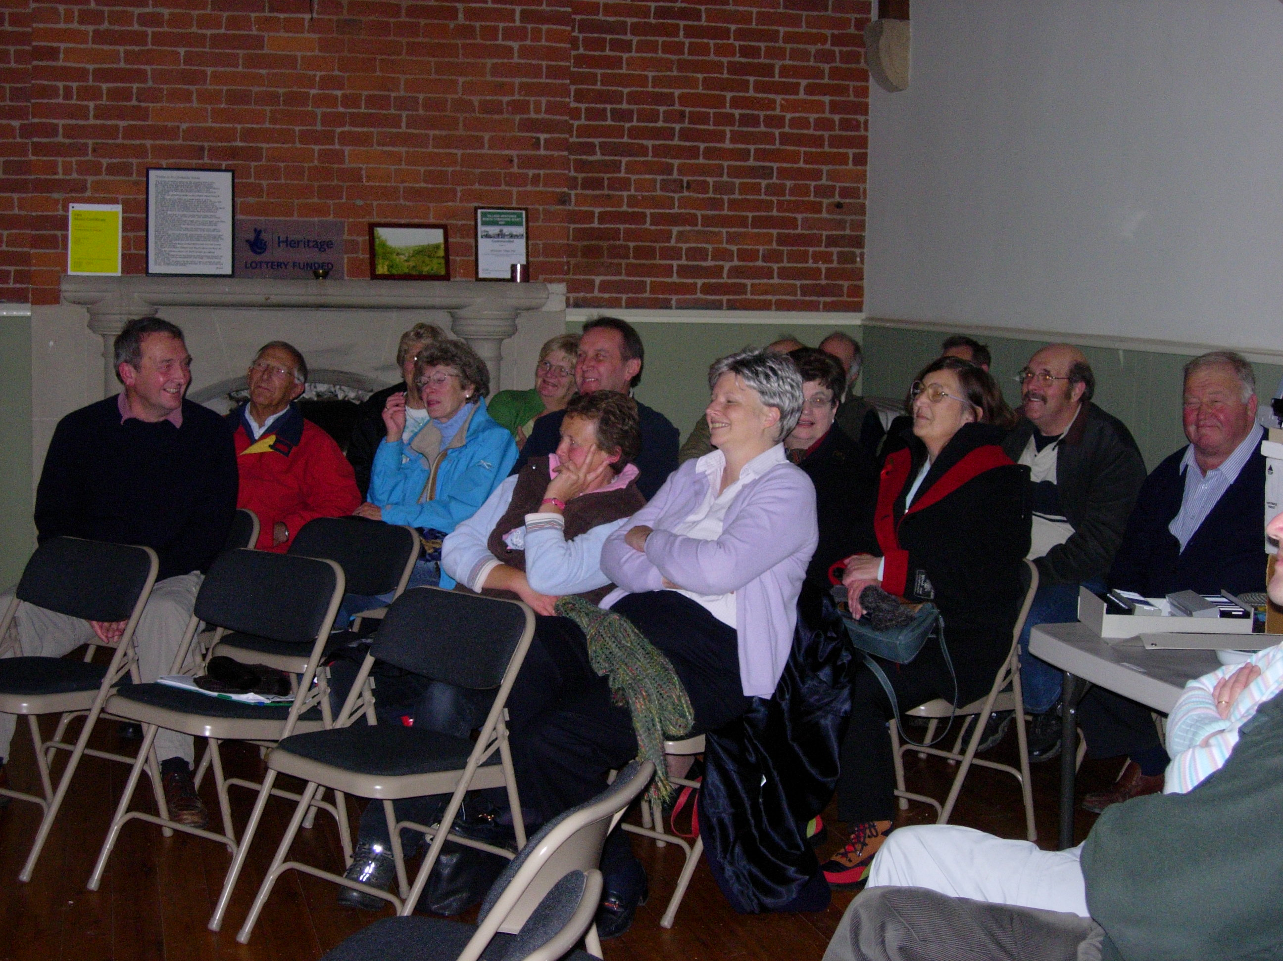
Most of the evening the audience were “in stitches” and it prompted many to request a follow up evening with the possibility of adding Super 8 Cine Film and Video from local residents.

Perhaps the most striking realisation was the extent of change within the village, particularly housing developments and many could be heard asking – “Where is that?” or “What was there before?”
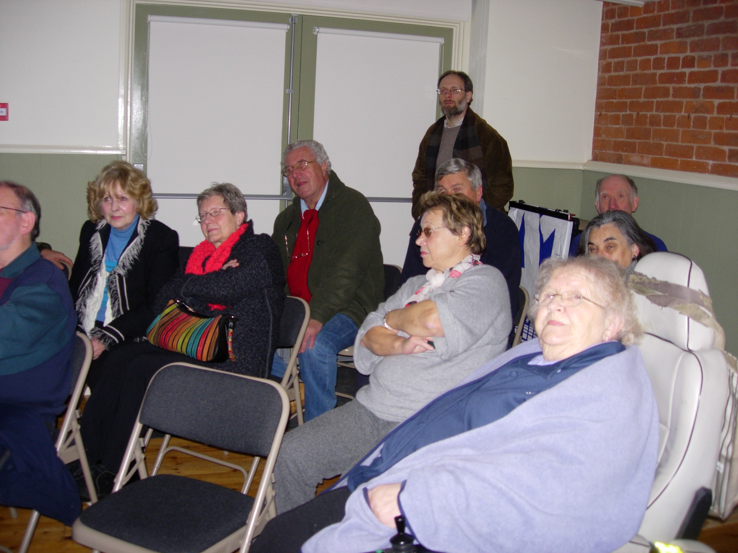

An idea for the High Wolds Heritage Group - a series of THEN and NOW photographs, with a photograph taken now, in the same location as an older one.

