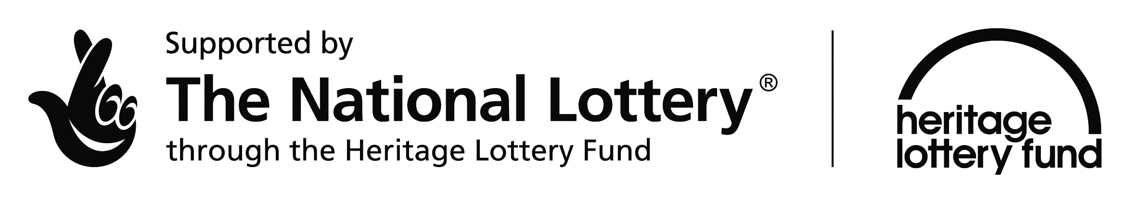
High Wolds
Heritage Group

The evening of December 11th 2008 brought together Ivy Eden and Chris Whitfield to present a hilarious “tale” of East Riding Dialect.
The audience of 15 braved the icy weather to hear a collection of tales.
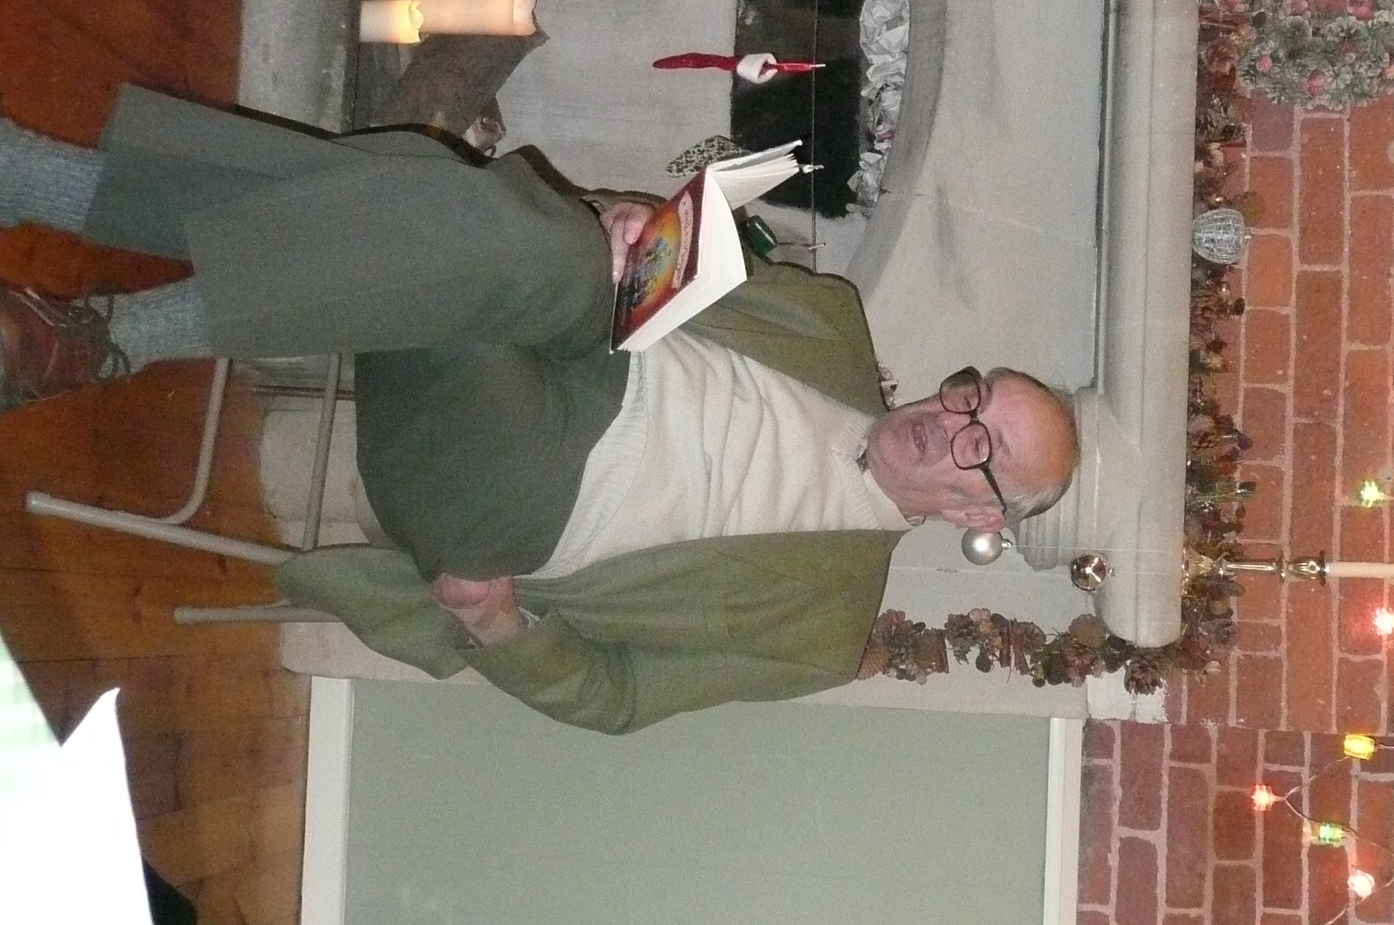
Chris’s repertoire included:
- Redbreast
- Fish and Chips
- Fire Engine
- Saddlers Shop
- Toilets
- Farmer’s Bullock
- Pig Killing
- Sylvester the pig
- Mrs Chew and her pig
- The Wrekling
- Vet
- Doctor
Themes related to
- Wives and Husbands
- Children
- Church and Chapel
- Medical
- Cricket
- Christmas
Ivy’s reminiscences, using hats for character change ranged around:
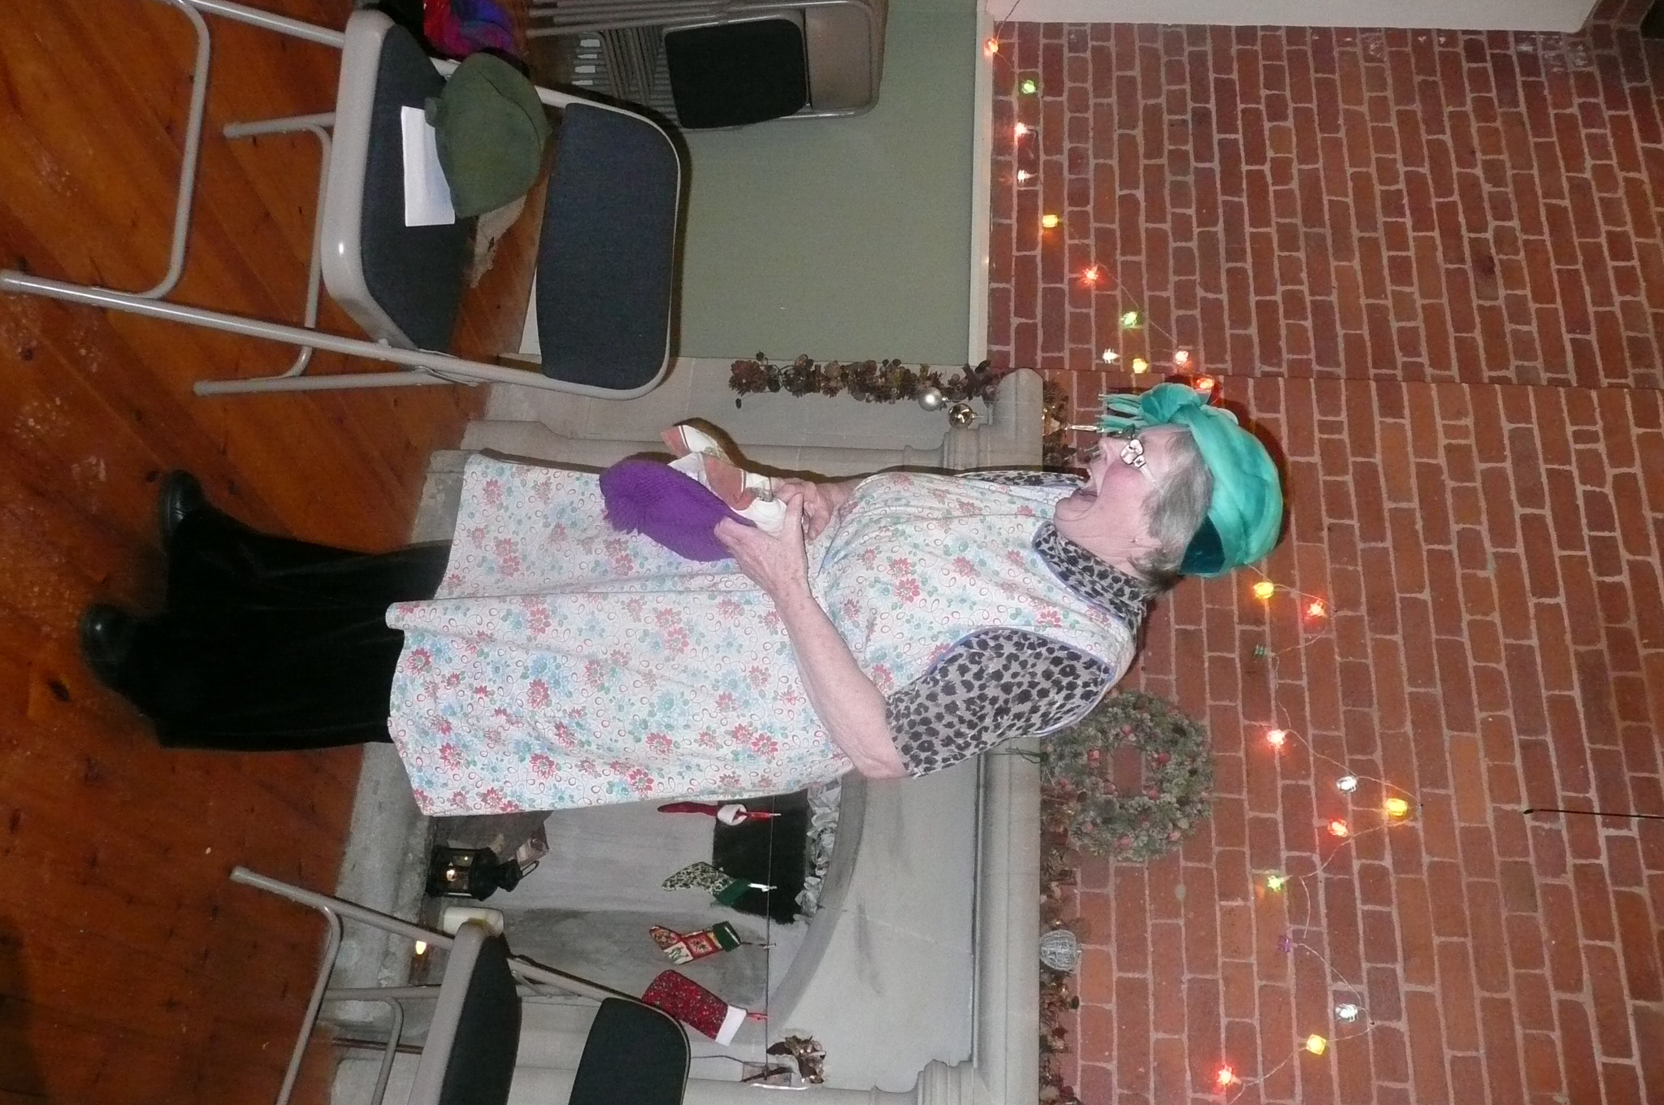
- The pianola
- Holiday in Windermere
- Marriage
- The washhouse
- Tights
The laughter continued through the ‘bring-and-share’ supper. A great evening!
