
Jan 22nd 2009 Training at ‘The Treasure House’ in Beverley
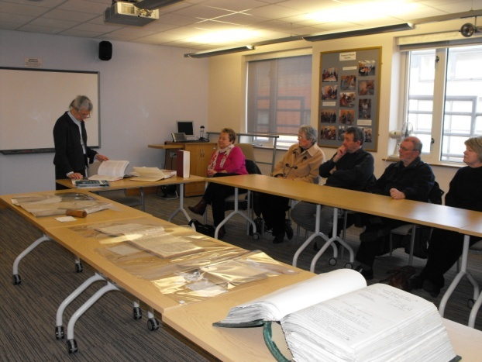

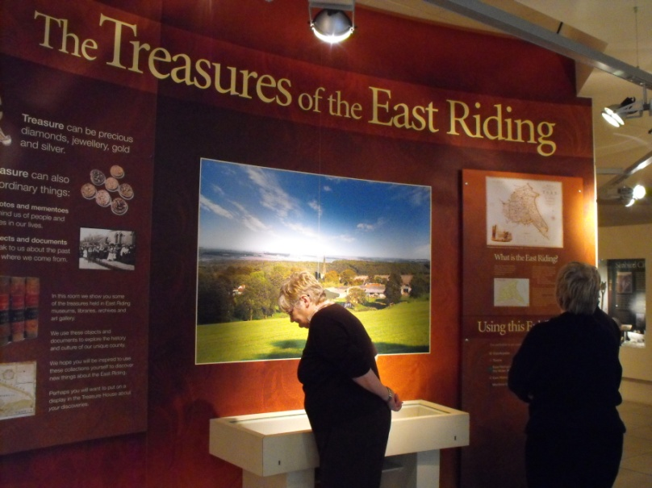
Some members of the group were given a guided tour of the facilities at the Treasure House at Beverley.

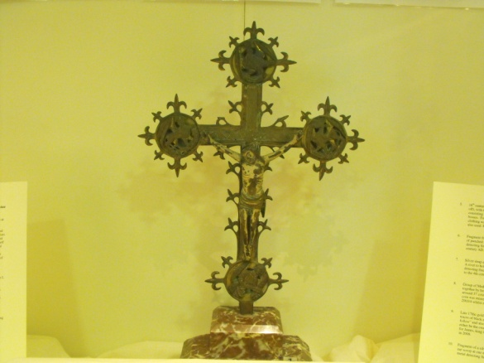
A few documents relating to the villages represented by the High Wolds Heritage Group had been brought out for us to inspect.

The valuable cross from St Mary’s church at Thixendale is now on display at the Treasure House.
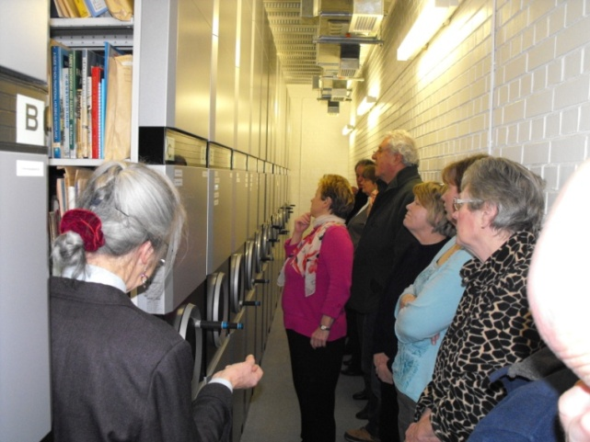

We were shown how items were archived and suggestions were given for suitable materials in which items should be stored.

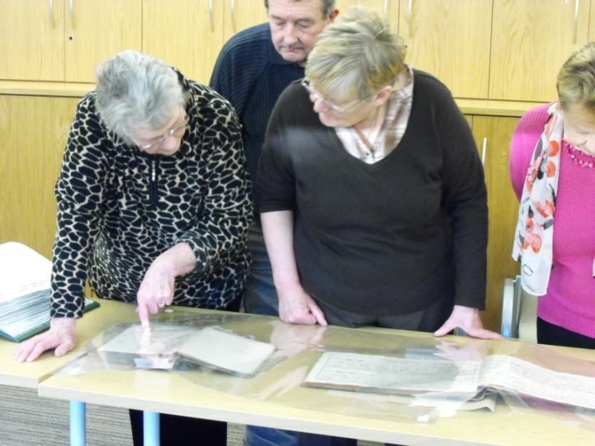

Ivy Eden inspects the marriage register from the church in Thixendale. By coincidence, the register was open on the page which showed the marriage of her parents.

