
High Wolds
Heritage Group
Opening of the Son-et-Lumière in St Mary’s Church, Thixendale
A sound & light guided tour round the church
Sunday 25th January 2009
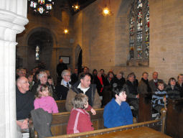
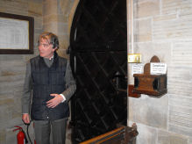
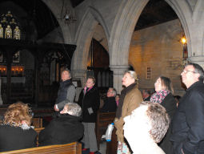
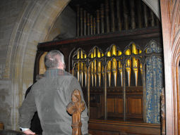
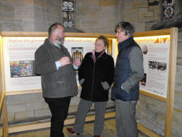
Pauline Foster and invited guests follow the Son-et-Lumière guided tour →
A grant has just been received from the Heritage Lottery Fund for restoration of the organ. Phil Thomas said “It’s like having a Rembrandt in the corner!”
Sir Tatton Sykes presses the button to start the sound and light tour
Phil Thomas, Pauline Foster and Sir Tatton in front of the information boards

