“The Malton & Driffield Railway”
An Illustrated Talk by Warwick Burton
March 2009

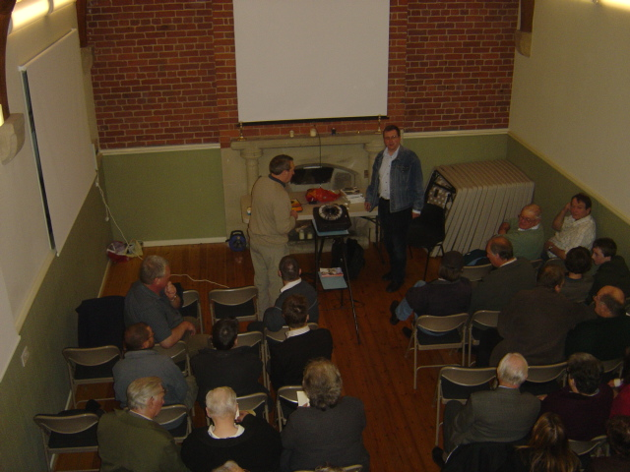

Thixendale village hall was packed!
Warwick Burton gave a most interesting talk about the MD railway.
Many who were there had read his informative book on the topic.
In the audience were some railway enthusiasts who are hoping to reinstate part of the line.

