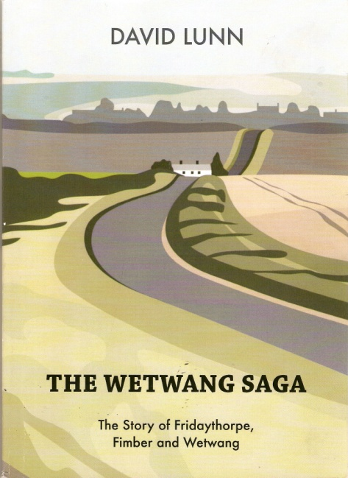
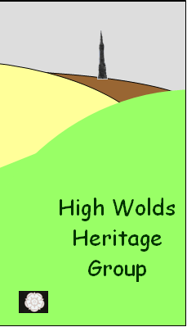
‘The Wetwang Saga’ by David Lunn
~
Book Launch and Signing
15th May 2009

David Lunn has completed his book about the early history of Wetwang, Fimber and Fridaythorpe. The High Wolds Heritage Group arranged an evening to launch the book. Invited guests and others interested in the history of the area were able to buy the book and have it signed by the author. We were pleased to sell 92 books during the event.
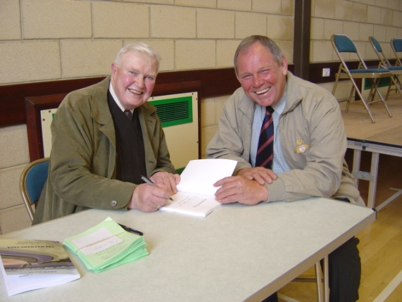

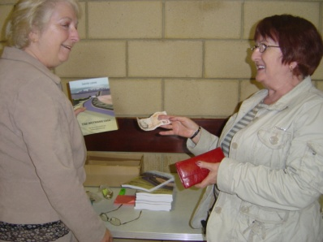

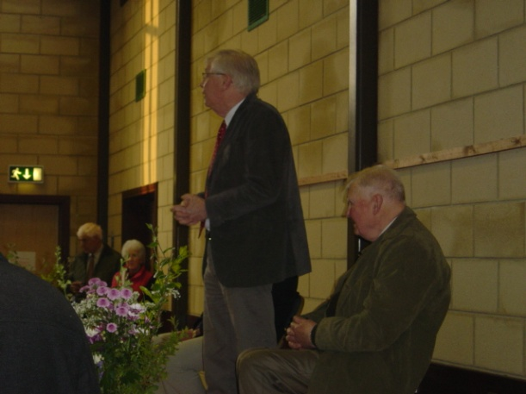
David Neave, an eminent local historian, said some words of appreciation of David’s book.

Bill Buckle and Chris Whitfield mounted a display of local history and Bill also showed an electronic presentation of old photographs. Both attracted much interest and sparked memories of days gone by.
