A High Wolds Heritage Group
guided walk around Sledmere

30th June 2009 Guides: Adrian Robson & Bob Beacroft

Background

Whilst villages have seen massive expansion during the latter part of the 20th century Sledmere has virtually stood still – the only new building in the last 50 years is the Fire Station (built 1968). In fact the housing stock has reduced as in the early 60’s Mill Cottages and Pry Cottages were demolished.

As we stand on the Estate Office steps we are surrounded by listed buildings – The Villa and Old Vicarage to the left, the village walls and walled garden opposite, The Triton Inn, The Post Office House and the Estate Office and House.

Tonight we are going back to Sledmere’s building boom – turning the clock back to 1895 when the Estate Office and House were newly built. The Post Office would be next but one of the old pair of lodges (to the Croome Estate acquired by the Sykes’s in 1812) would still be standing and was being used as The Post Office. The Wesleyan Chapel of 1889 would of course be relatively new and there were just two further pairs of cottages on Croome Road. Other buildings in existence: Gardeners Row, The Triton Inn with stabling to the rear and a blacksmith’s shop, opposite Triton Cottage and Home Farm.

There was no excuse for bad time-keeping in Sledmere – there were three clocks – the Buildings Yard, the Home Farm and the Stable Yard! As we will see later in the Buildings Yard in 1942 the Agent even laid down the leaving work times for when men were employed away from the Estate Yard. The Estate Office is built up to a higher level than the street and with no hedge, just the wall, this may well have enabled the Agent to keep an eye on the workforce to make sure they were keeping “good time”!

Inside the Estate Office
Much of the fittings would be the same as in 1895 – note the stand-up desk. The walls and paintwork would be very much darker in Victorian times – Adrian can remember it being dark green and cream at one time. The heating would be the open fire and you can see the “S” for Sykes in the surround – the office has its own log store to the rear and the woodmen would come and replenish this at regular intervals.

Of course in the days before paying for goods and wages by the BACS system and popping down to the bank in Driffield was a couple of hours job, a safe was an essential piece of kit. Rent day twice a year was a big event!

Fortunately for today’s historians, the landed estates kept extensive records of virtually everything – just how money was received and spent and to whom and for what. In this cupboard is what will eventually be held in the Brynmor Jones Library at Hull University with the rest of the Sledmere Archives. At the moment they are still too time sensitive to enter the archive. The archive of course remains the property of Sir Tatton but is available to both academics and members of the public to do valuable research. As you can see the old books and ledgers have wonderful bindings and some are still being used and unfortunately may be abandoned before full in favour of a computer system!

For example they kept records of the use of labour in the Buildings Yard – the Buildings Yard Labour book covering 1895 to 1899 records on 2nd April 1896 the start of the pulling down of the old Post Office/Lodge and in March 1896 Bob’s Grandfather’s name starts to appear. You can also see when someone is off sick – not often – it’s recorded as “charity”. Christmas Day was also recorded as “charity” and you can see exactly how many men were on the payroll at Christmas 1899.

We also have the Wood Sales book from 1912 to 1942. This shows sales to tenant farmers of fencing stakes, gates etc but also major wood clearance sales to Taylors Timber Merchants of Driffield which were very often by tender. It’s interesting to note that a load of logs for tenants was 10 bob but for ERCC (for the school) was 12 bob!

Moving to the Map Room. This has maps covering the whole of the Sledmere Estate which at this time extended to some 34,000 acres – Fimber, Thixendale, Garton, East Heslerton, Kirby Grindalythe, Kirkburn, Wansford, Weaverthorpe, Wetwang, Bishop Wilton plus some 2000 acres in Holderness.

Plans for the Agent’s house in the park are also set out. This was never constructed. Note the description of a “Motor House” instead of a “Garage”. These we think might date from the early 30’s. Henry Cholmondeley retired as agent in 1928 and was succeeded by Adrian Scrope, brother-in-law of Sir Richard, so it was perhaps designed for him (he went to live at Wold House, Nafferton).

The Post Office
As you will see from the Buildings Labour Book they started pulling down the old Post Office/Lodge on 2nd April 1896 and on 16th April 1896 work commenced on the new one. The Post Office closed in 2008 and there were plans to open a facility at The Triton but this never materialised and therefore we no longer have a service in the village.

The Post Office as we see it remains largely unchanged from the day it was built. The security screens were an addition in the 70’s. The door that leads to behind the counter was where the public telephone was – see the glass in the door.

As we go across the road towards the walled garden note that there was once a hatch in the wall to enable villagers to purchase produce.

Another point to note is the damage to the wall. This was done by an armoured tank! During 1943 Sledmere was the base for a tank division training for the D-Day landings. For 16 months land from over 475 farms was used for intense training in tank warfare resulting in deeply rutted tank tracks, gun pits and many, many gaps in miles of hedging and fences. In the Spring of 1943 these farmers were compelled to sell their livestock (some 58,000 sheep!). When training began, hundreds of tanks, thundered through their cornfields, turning them into a sea of mud. Hedges and fences were flattened under the tracks; infantry sought cover in their woods; artillery dug heavy gun emplacements in their pastures. Day and night, during manoeuvres, they were in the midst of battle. Only a small “home pasture” of about 25 acres was safe from the training operations. Mr William Hodgson was convinced that every battle fought seemed to converge on his land near Octon Crossroads!

The Potting Sheds

If you have ever visited the walled garden at Sledmere you probably wondered what lay on the other side of the wall to the glasshouses. Here we have the working side of the gardens. In 1895 a Welshman, Robert Roberts was the Head Gardener and lived in No 3 Gardeners Row. He was appointed in the early 1880s and served for more than 30 years. He would have had a team of 4-5 gardeners under his command.

As we enter the potting sheds note the hatch down to the fuel store. The present boiler of course relies on oil but its predecessor would have been coke fed - a time consuming job ensuring the boiler didn’t go out. The original 4” pipes can be seen which would have helped in heat retention if such an event occurred. Each country house set great store by the amount of exotic fruits which they could provide for their dining table – citrus fruits, figs, grapes, nectarines and most prized of all, pineapples.
The gardens would have been a good place to work in the winter – plenty of work in the warmth of the hot-houses and even the potting sheds have open fireplaces and these are still used in the wintertime today. There would most certainly have been an apple store but there is no visible sign of this today, neither is there any visible evidence of where the mushrooms were grown but again this activity would have taken place. There was very little mechanisation. The Home Farm would have taken a crop of hay from what we today regard as the lawns and indeed there is a well known Henry Thelwell photo of haymaking in front of Sledmere House. There were no hosepipes and rainwater from the glasshouse roof was channelled back into tanks in the glasshouse so that it could be used on the plants at the right temperature. Here we have early examples of watering pumps.

As we go through the walled garden it’s worth pointing out that the central wall which divides the garden in two has heating pipes to promote the growth of soft fruit on the wall. The garden covers some 2½-3 acres. We are not visiting this as in the Victorian era it would have been given over exclusively to the production of fruit and vegetables – indeed “Tatton the Eccentric” hated flowers and did not even like his tenants to grow them! If you have not visited the garden it is well worth a visit and won gold in the Britain in Bloom competition last year.

As we exit the garden, the door in the wall opposite was for the exclusive use of the vicar – The Vicarage is opposite and this enabled the vicar to walk through the grounds in a direct route to the church and this became known as The Vicar’s Walk. The newly built church at this time would have no perimeter fence, it merely stood in the grounds of Sledmere House. Rev Salter was the last Vicar to use this regularly (had the living 1947-53). The Vicarage was sold by the Church Commissioners c1998 when the benefice was reorganised.

We will exit the House grounds via the main gates at The Lodges and visit The Well.

The Well
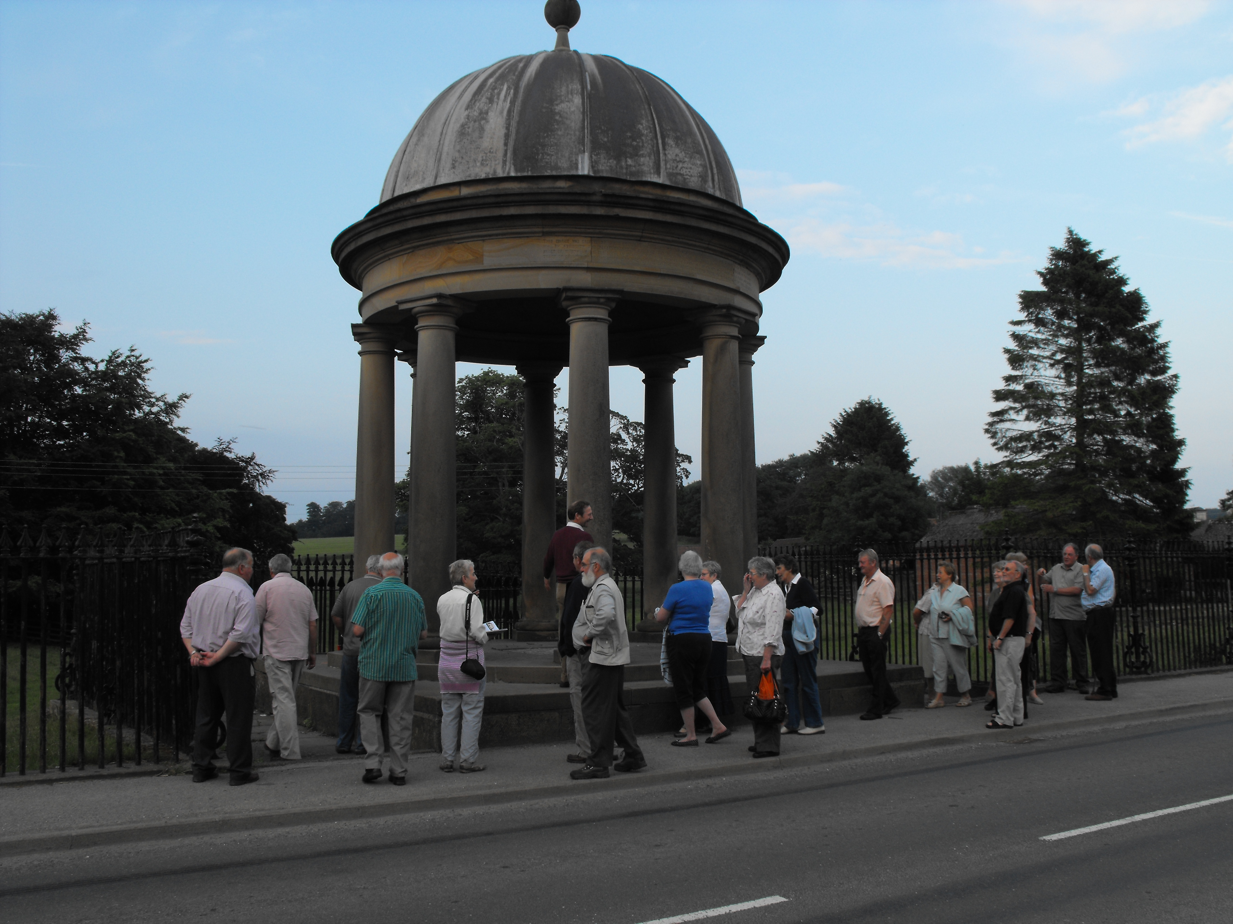
The village well was dug in 1785 and is 97 feet deep. (Sledmere House has its own well which is approx. 167 ft deep.) It was covered in 1840 – a classical rotunda with eight columns supporting a dome – by Sir Tatton Sykes I as a memorial to his father, Sir Christopher.

In 1890/1 a small waterworks with reservoir on Kirby Road was constructed chiefly for the use of Sledmere House. The waterworks were extended in 1914 and village houses supplied but outlying farmers were not attached to mains water until the mid-1940s.

The Estate Buildings Yard
We conclude our tour in the Buildings or Raff Yard. Why is it called the Raff Yard Bob? Today with so many listed buildings to maintain, the Raff Yard resembles an architectural salvage yard!
The Clerk of Works Office and the large workshop were designed by Frederick Latham and built in 1902. From the Buildings Labour book we looked at earlier there were 43 men employed in the Raff Yard at Christmas 1899.

There were many cottages and farmsteads and buildings to maintain as well as the construction of new buildings. As the estate covered a large area it would involve the men taking lodgings in the various villages while work was carried out.

The Clerk of Works Office The Surgery (for the travelling doctor)

The Hardware Store The Paint Shop

The Coke Store The Lime Shed and Cement Shop with its old water pump

The Salvage Store The Workshop



