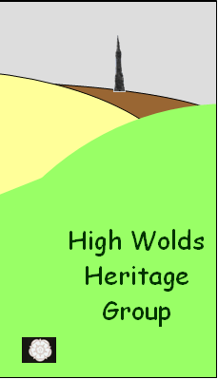
HISTORY EXHIBITION AT WETWANG
The High Wolds Heritage Group History Exhibition in the Wetwang village hall over the weekend 19th and 20th September was the culmination of weeks of hard work for the members from Wetwang, Fridaythorpe, Fimber and Towthorpe. The amount and variety of the exhibits astounded everyone. The main part of the exhibition dealt with Wetwang and was split into sections covering farming in the village, the village school, sport, shops and trades, the village hall, the church, the chapel, the railway, family history, geology of the area and archaeology. There were also displays of village history from Fridaythorpe, Fimber and Towthorpe, a slide show of ‘Wetwang Then and Now’ and a short film of a Fridaythorpe resident recalling her memories of the village. The display boards and walls were adorned with hundreds of photographs of the villages, many not seen in public before. In addition to all this, a display of memorabilia by the Wetwang Branch of the Yorkshire Countrywomen, covering the period from 1820 to 1950 gave the finishing touch to an excellent exhibition.
Comments on the visitor’s sheet such as, “Amazing! What a spread of research and information. The best village exhibition I’ve ever seen. Well done to you all” “So good – coming back later”, made all the hard work worthwhile.
If you have any knowledge of the history of Wetwang, and the other villages involved, interesting stories about the villages, or photographs you would like to share with us, please do not hesitate to contact me, W. Buckle, at wetwangtattler@btinternet.com.
The HWHG is funded through a grant from the Heritage Lottery Fund. Membership is open to all and is free.
Some photographs of the exhibition —
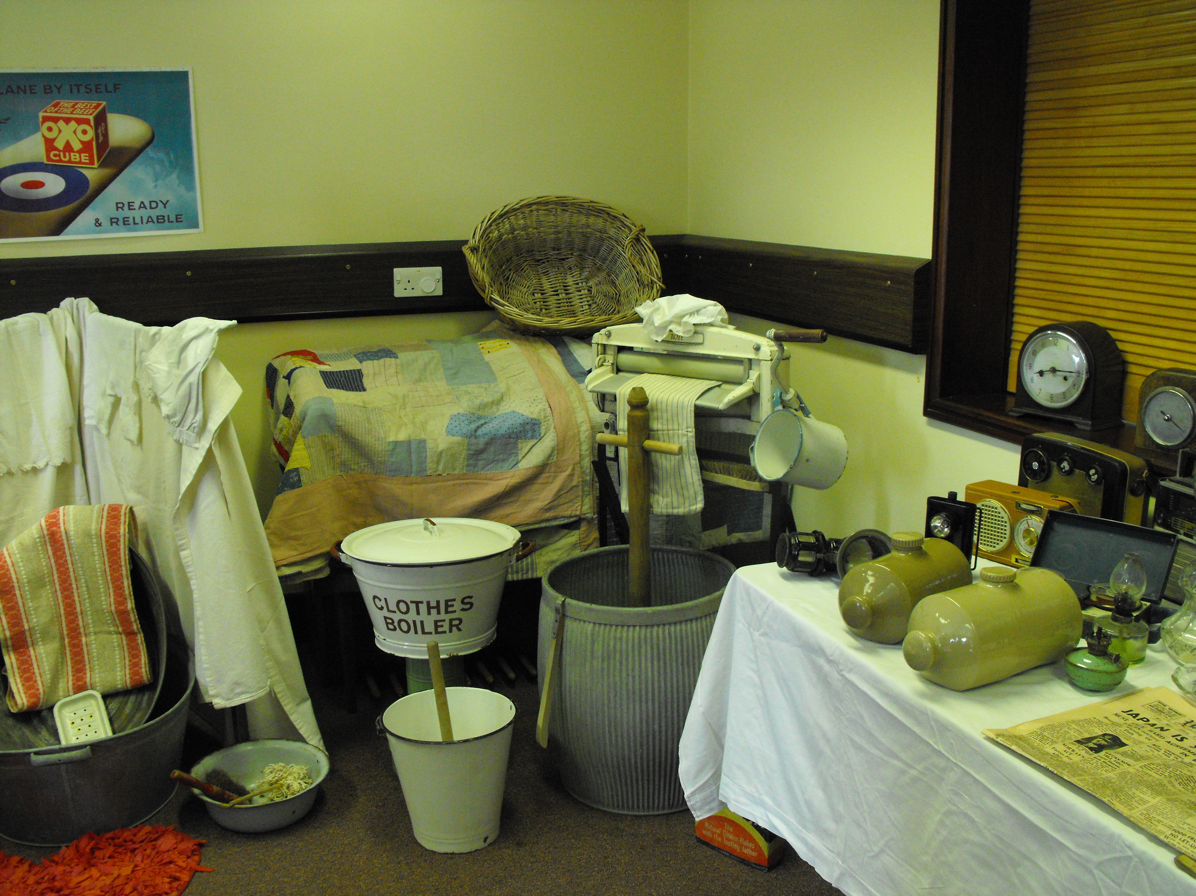

Reena Scrowston, Eileen Sunderland, Dot & Bill Buckle


