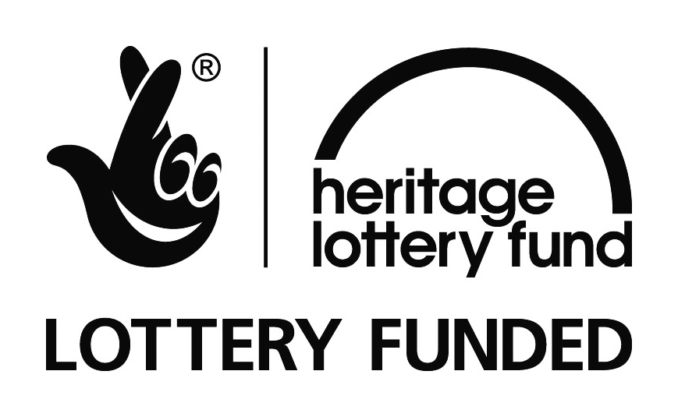
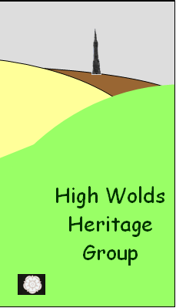
East Riding Dialect Evening
Friday October 16th 2009

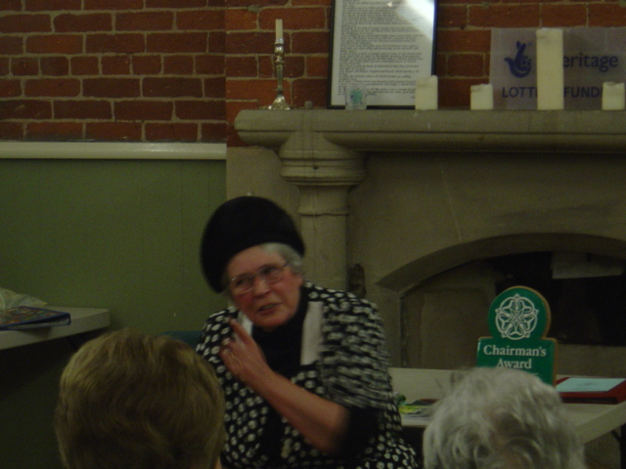
Members of the East Riding Dialect Society provided a most enjoyable and entertaining evening for an appreciative audience of around fifty people. The Chair of the East Riding Dialect Society, Don Bemrose, welcomed everyone and explained a little about the society which he established 25 years ago, so this year has been a celebration year. The group has almost a hundred members who collect, write, publish and record stories and poems in East Riding dialect with the objective of keeping the East Riding dialect alive. Five of their members came to Thixendale and shared some of their material with us.
Ivy Eden performed a monologue which involved four women and a vicar, identified by their different hats. It was amazing how she could keep the voices for each character different and remember which hat to put on.
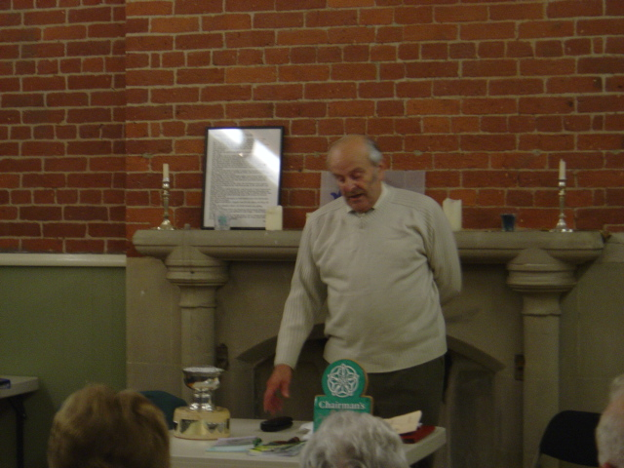
Chris Whitfield followed with a wonderful stream of amusing stories about colourful characters from nearby villages.

Peter, from slightly further afield, made a guest appearance reading three of his own narrative poems about his village pub.
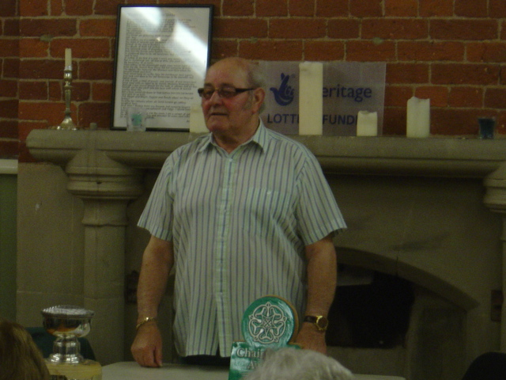
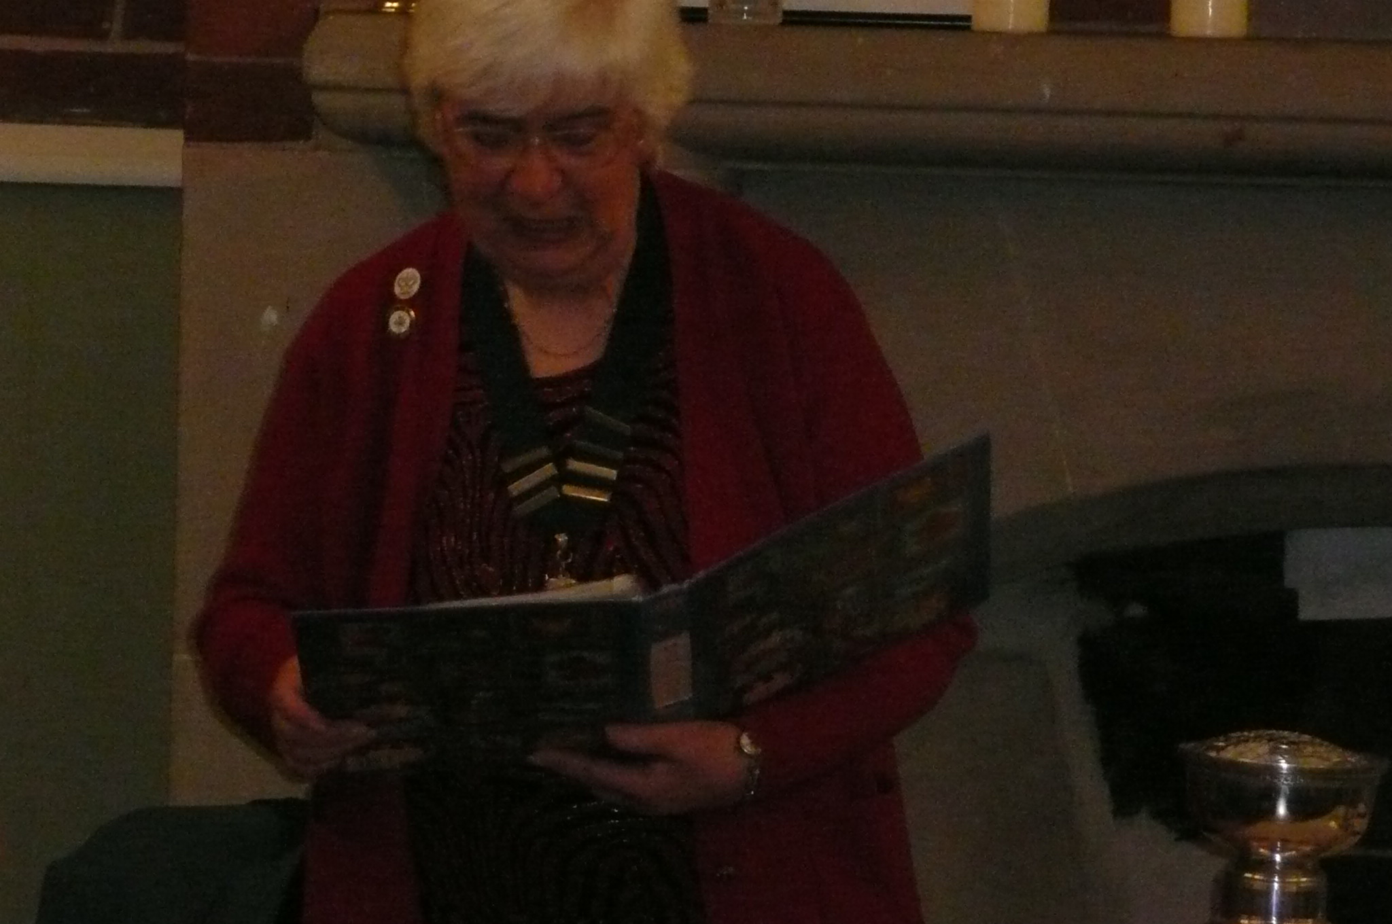
Audrey Bemrose writes a lot of her own material and it was most interesting to hear her poems about members of her family. She has done a great deal of research into her family history and we were fascinated to learn about the family links that she has discovered with several of the villages and hamlets in the High Wolds Heritage Group area. Don Bemrose brought the evening to a close with one or two humorous readings from his recently published book of memoires in dialect verse, ‘Diz thoo Rememb’r?’ and ‘All in all a ‘raht gud night!’

