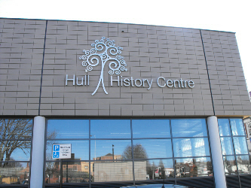
Visit to the Hull History Centre – 2nd March 2010
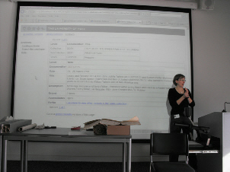
Several members of the High Wolds Heritage Group were able to spend an interesting afternoon at the centre.

Judy Burg introduced us to the facilities offered by the centre for research into a variety of aspects of local and family history. She had found a selection of items appropriate for the villages represented in the HWHG and displayed them for us to inspect.
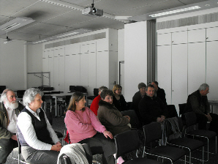
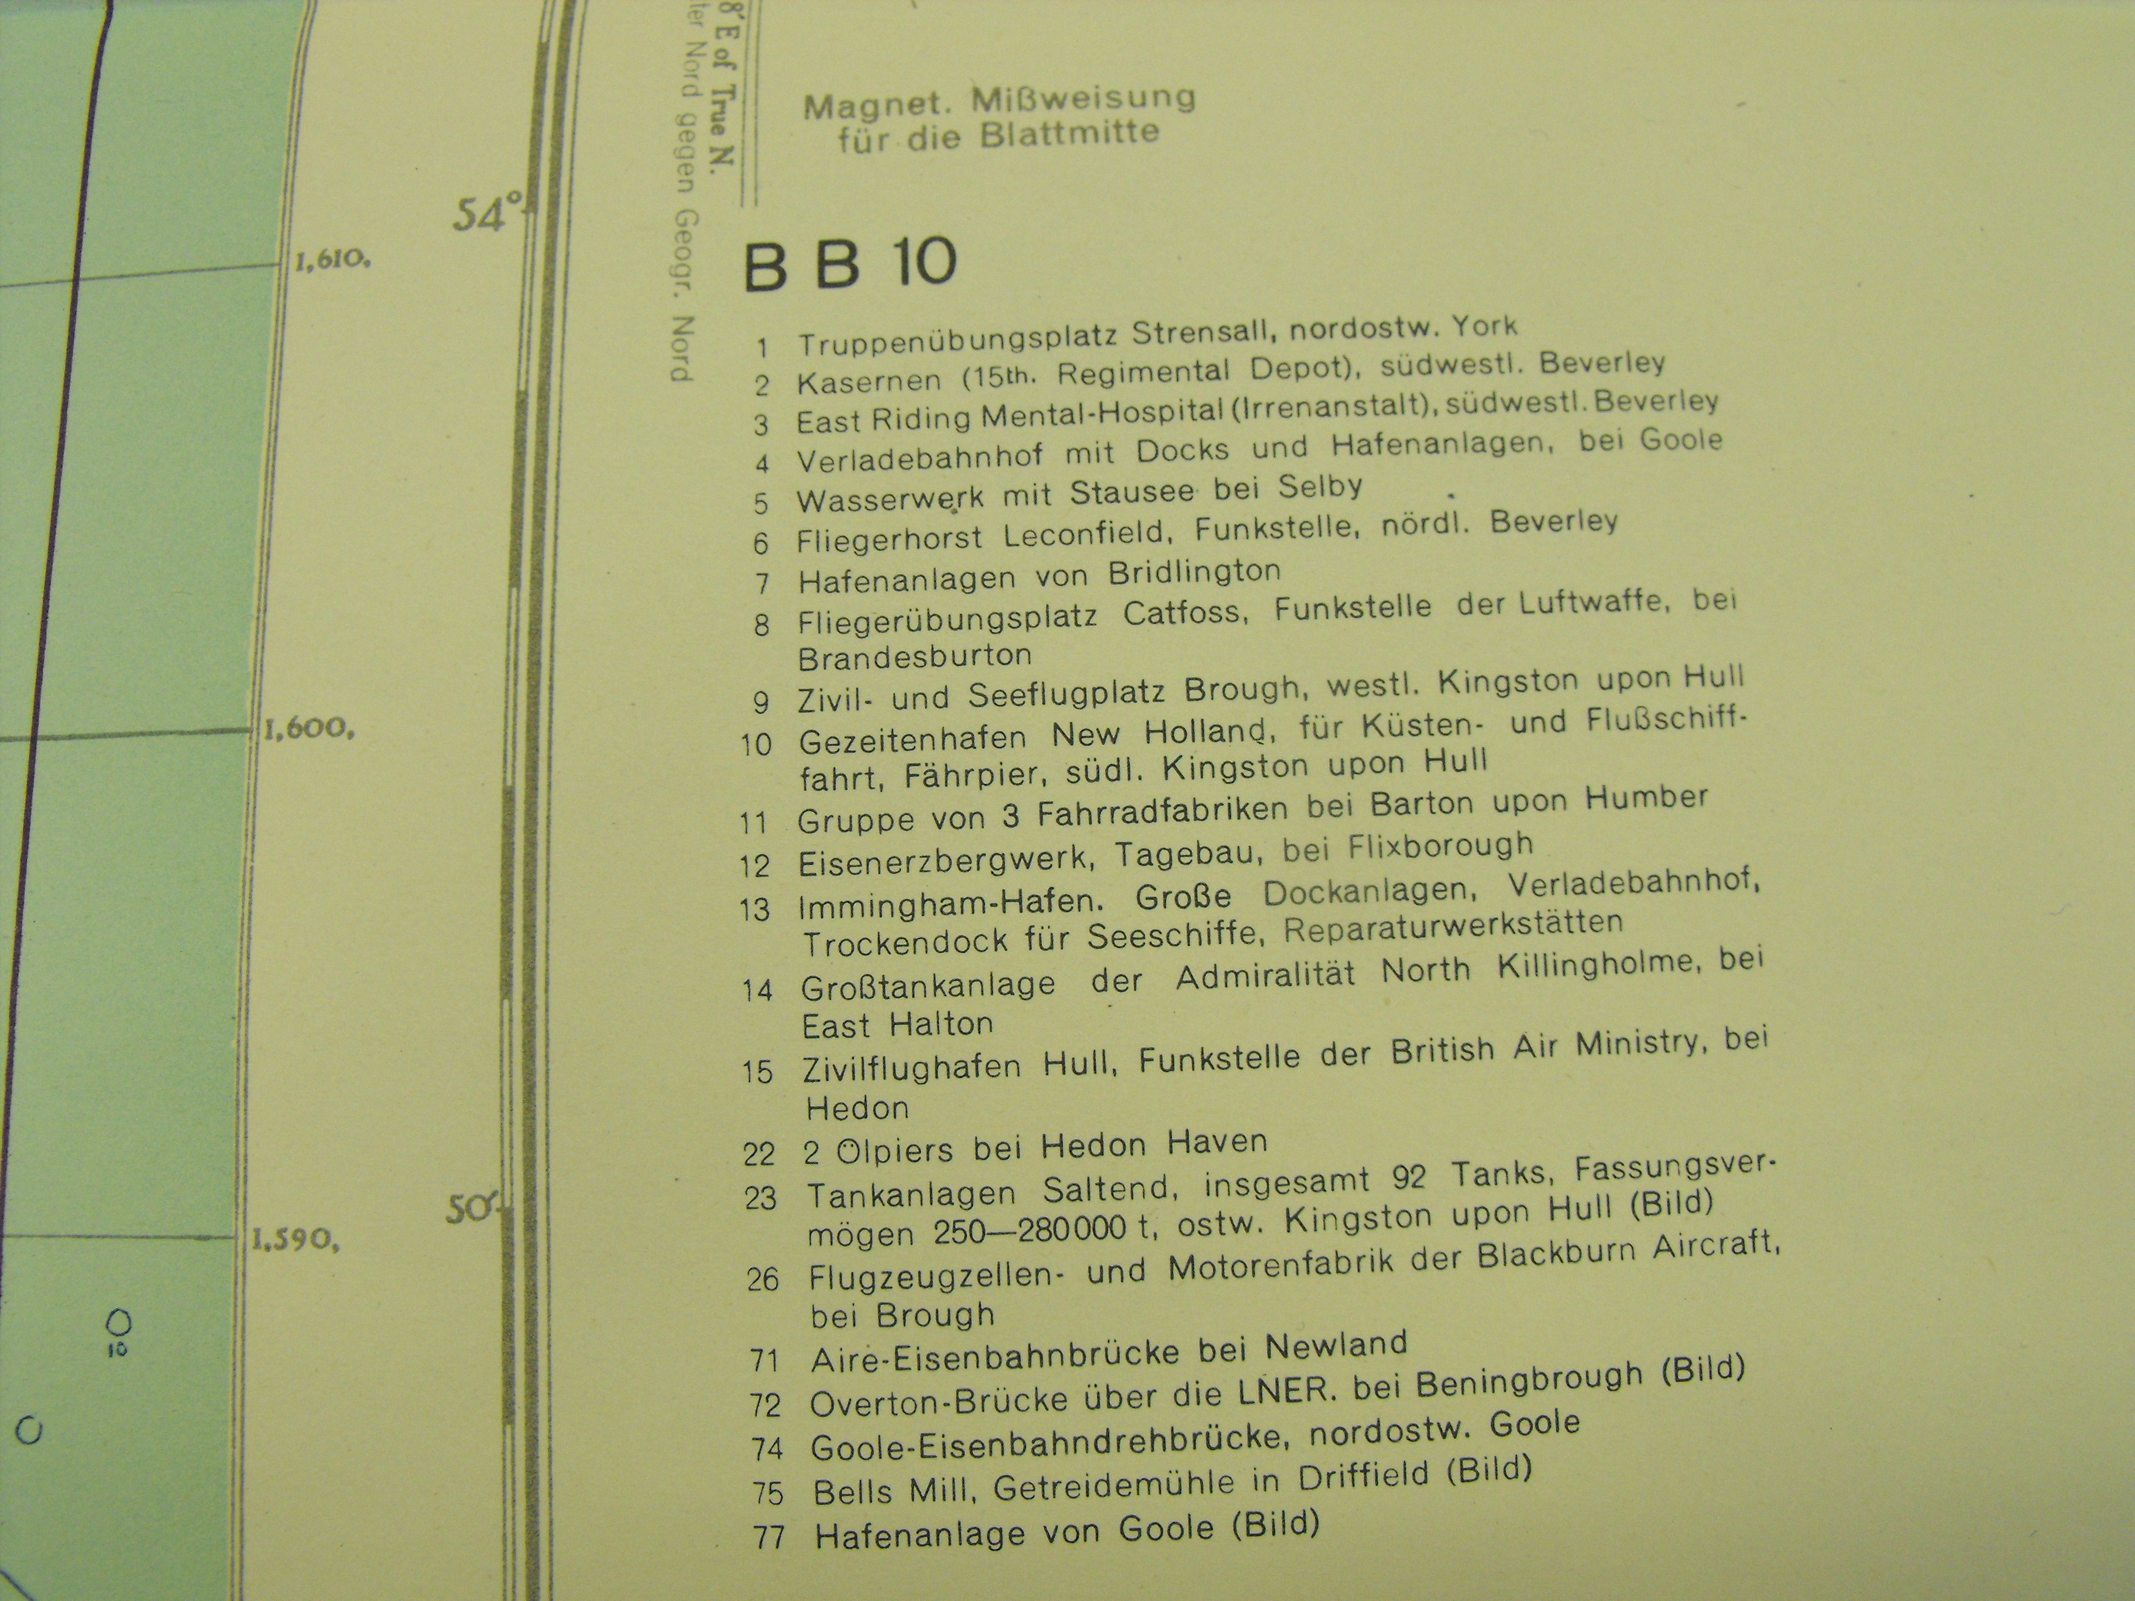

For a small fee, we were allowed to take photos of a German map of the area which showed airfields and other strategic sites that the Germans might bomb during World War II.

The photograph here shows the key, but the HWHG were able to purchase a copy of the map.

