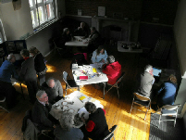
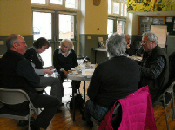
The purpose of the event was to collect information about the impact of war time on the Yorkshire Wolds in preparation for the forthcoming exhibition about the topic in June.
People came along to the village hall in Thixendale to share memories of life in the Yorkshire Wolds during the 1st and/or 2nd World Wars - either their own memories or tales told by relatives.
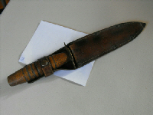
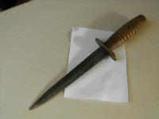
Some interesting objects were brought –
A scabbard in its original case, brought by Mr Gerald Mumby
It is shown on A6 paper.

Below is a mystery object, found on farmland. The ring is about 2in (5cm) in diameter. Do you know what it is?
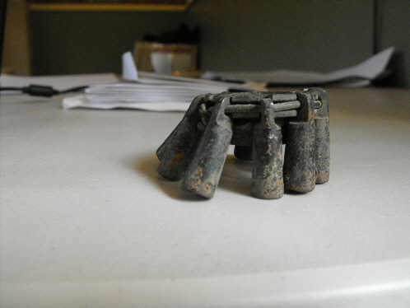
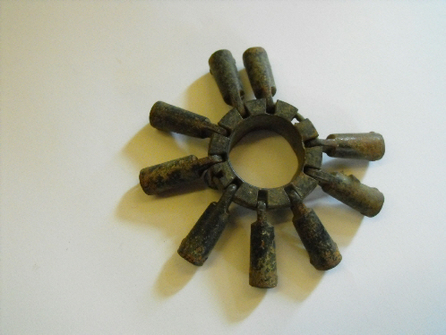

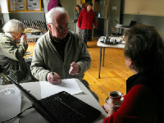
The photograph on the left shows Mr. Stephen Lawrence, of Driffield, talking to Pauline Foster about his life growing up in Thixendale. His mother was Headmistress of the school.
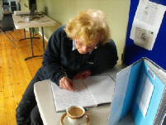
Pricilla Truss of Leeds recorded the memories of relatives in a book as a permanent record for the High Wolds Heritage Group.
Some people volunteered to be interviewed for the oral history project to record their memories of life on the Wolds.
Photographs and other documents were scanned and photographs were taken of objects.
The afternoon was a pleasing success.

