

A Talk about “The Land Girls” by Dorothy Taylor
Thursday 29th April 2010

During World War 2 Dorothy Taylor was a Land Girl.
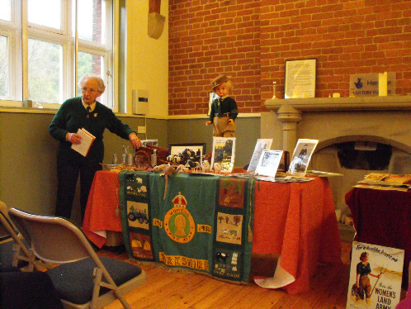
Her talk was extremely interesting and amusing, illustrated by a wonderful display of photographs and artefacts, including the medal and certificate for the OBE awarded to Miss Winifred Jacob-Smith in 1951, shown below, for her services to the Land Girls during the war.
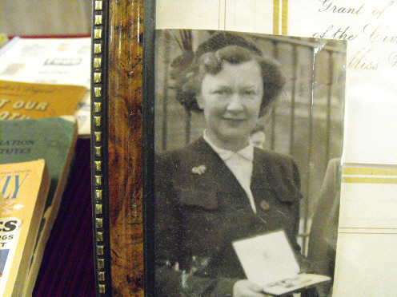

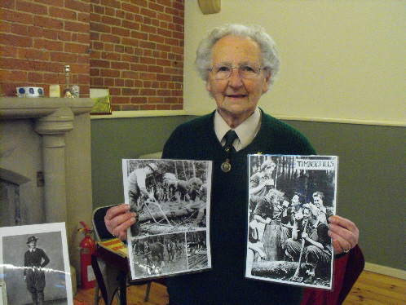

Dorothy shows a photo of ‘Timber Jills’
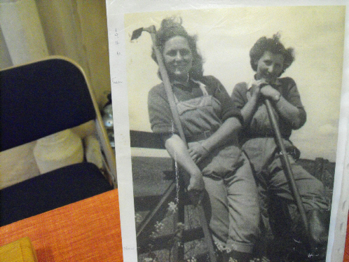

Dorothy (right) with Joyce Colbeck (left)

Dorothy’s story is told below.

One Woman’s War — Dorothy Taylor — Land Girl
In 1944 when Dorothy Taylor was sixteen she had to register for war work and as she did not want to work in munitions she decided to find something else. She had been working in an office since she left school but when she discovered that a local farmer, who was also a milkman, was looking for someone to replace a land girl who was leaving his farm she jumped at the chance of working for him as a member of the Women’s Land Army as soon as she was seventeen.
The working day was much longer than her office hours and the pay was less too but Dorothy had a good employer who treated her like one of the family and she soon settled into the work.
Her main job was helping with the hand milking of 40 cows. When the milk had gone through the cooler it had to be ladled by hand into milk bottles which she then had to deliver using the horse, Bess and a milk float. Her first task on returning to the farm was washing and sterilising hundreds of dirty milk bottles ready for filling the next day.
Work wasn’t finished then though. There were pigs, chickens, calves and the bull to be fed. The hardest jobs were cutting hay from the stack and hedging and ditching which Dorothy thought was a dirty smelly job.
Her favourite part of the day was looking after three horses and riding if she had the opportunity.
Dorothy became good friends with Dolly, another land girl who shared the work and the ups and downs of life on the farm. One winter’s day a War Agriculture van skidded on the ice and crashed into Dorothy’s milk float. Bottles and milk flew into the air and Bess took off with the float behind her! Milk was on short rations for everyone that day.
When her friend Dolly left to become a milking instructor to other land girls, Dorothy and her sister Clarice found places for two land girls on a farm near Bridlington. Unfortunately the accommodation was a tied cottage which was very run down and dirty with no water or electricity. The work was mainly fieldwork with some milking but everything was done in an old fashioned way and Dorothy often found herself thinking fondly of her milk round days.
That winter happened to be one of the most severe on record; blizzards and freezing temperatures went on for days and all the roads were blocked. Sheep were buried under drifts of snow and had to be dug out. Dorothy and her sister had to melt snow for washing and would carry Kilner jars of fresh water for drinking from the farm.
One task which Dorothy had not done before was hoeing turnips. At the end of the first row she thanked the foreman, Jack Taylor, for helping her to finish her row. ‘Don’t thank me’ he said crossly ‘I’ve left turnips—you left weeds!’ He must have forgiven her though because some time later she married his son Charles, who was shepherd on the farm. So her time in the land girls was really just the start of life on the farm for Dorothy.
Many, many years later Dorothy started the East Yorkshire Branch of the Women’s Land Army Association which meets socially and formally for Remembrance Day parades and other events. She is proud of the contribution to the war effort made by the Women’s Land Army and enjoys sharing her experiences with children in schools and through giving talks to different organisations. Her petitions helped to gain recognition for the efforts of the thousands of women who served the country in the Women’s Land Army and the Timber Corps. It was only in 2008 that the thousands of women like Dorothy, who worked in the Women’s Land Army and The Timber Corps were recognised for their efforts with a commemorative badge. Representatives were invited to Downing Street to receive their badges. Many others attended receptions at their local County Hall.

