

“Wartime on the Wolds”
An exhibition at Sledmere House
Thursday 26th & 27th June 2010

As part of the Nostalgia Weekend at Sledmere House, the High Wolds Heritage Group presented an exhibition showing how World Wars 1 & 2 impinged on the lives of people who lived on the Yorkshire Wolds.
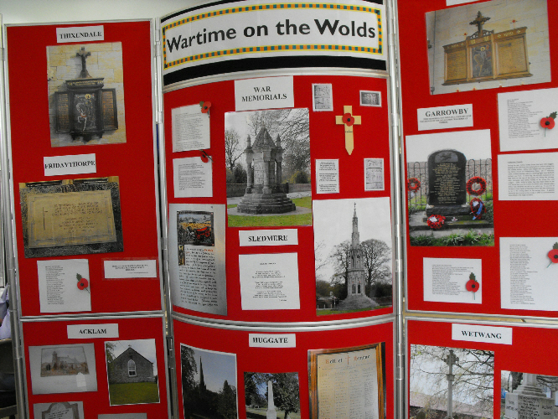
Visitors were welcomed by a selection of photographs of war memorials in the villages of the High Wolds. Other displays showed a selection of uniforms and rifles, items of everyday life including ration books and sheet music, and the Home Guard.

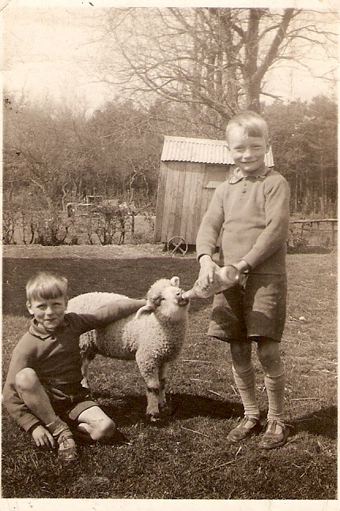

Children from Sunderland and Hull were evacuated to villages and farms on the Wolds, and transcripts of oral history interviews with people who had been evacuated were presented together with photographs of the evacuees during wartime and present day.
George and Gordon Alcock at Westfield Farm, Fimber →

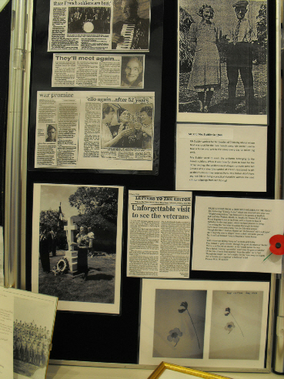

A battalion of the Free French Army was located at Fimber and a display described their activities, illuminated with photographs. Luckily, we still have contact with some members or their descendants.

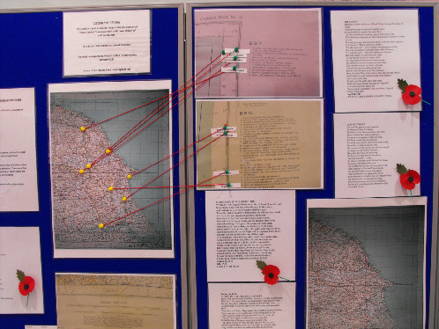
A copy of a German map was displayed — it identified sites in the Wolds which the Germans considered of strategic importance – some surprising locations!
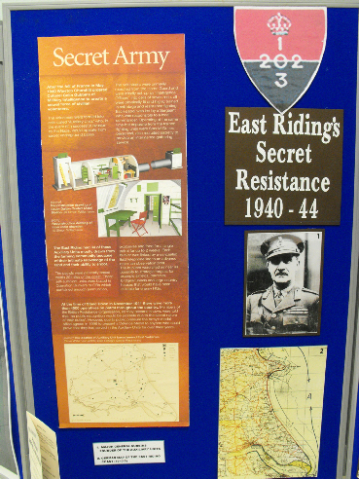
The author of “East Riding Secret Resistance”, Alan Williamson, presented detailed diagrams of the Operational Bases used by the Secret Army, maps of their locations and details of responsibilities.
Several copies of his book of the same title were sold [ISBN no. 1 904474 21 7].
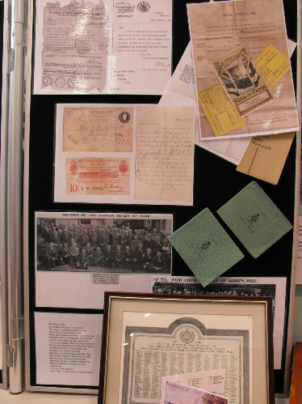

Another interesting display was about some relatives who had served in the Great War.

Items about home life –
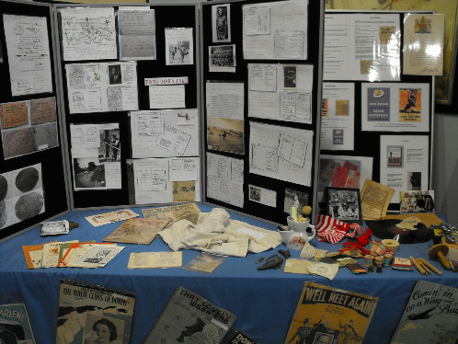

There was so much more on display than can be shown here.
Visitors said they found the exhibition most interesting and informative and commented on the excellent quality of all the displays.

All the hard work resulted in a successful weekend!

