

A visit to Huggate Dikes, the church and the Well
Wednesday 14th July 2010

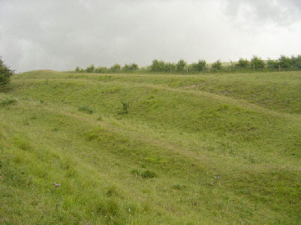
With dark clouds looming in the distance, we set off from Wold House Farm to drive the short distance to our first stop - Huggate Dikes.
Huggate Dikes are part of an extensive system of linear earthworks believed to have been made during the Bronze Age. Sue and Alec Dale, who farm the land, explained the various thoughts of different archaeologists about the function of the dikes. The well known local archaeologist J R Mortimer from Fimber wrote at length of his investigations into the earthworks and burial mounds of the Wolds during the 1860s. He calculated that there were at least 80 miles of linear workings within the area he studied from Wetwang to Garrowby. No-one is really sure of the purpose of the linear earthworks but conjectures are –
- A boundary between the lands of one tribe and another
- A form of defence against invaders
- A way of containing livestock
- A route between one place and another.
There is a natural, probably ancient, route along the earthworks in Horse Dale, near Fridaythorpe, on to Huggate Dikes, into the upper part of Frendal Dale and thus into the whole of the Millington complex, which supports the latter theory. The lines of parallel ditches are sometimes interrupted by small flat areas which could have been places to rest on a journey or meeting points to buy and sell goods.
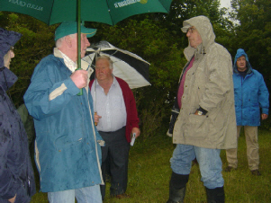
Originally, the earthworks would have been even more pronounced, the troughs deeper and the banks higher. Over time they have been eroded to the size they are today. They are all the more impressive when you consider the tools they had to work with – probably made from antler and bone. The ground is shallow soil over solid chalk.
Unfortunately, the dark clouds rolled in and, due to the heavy rain and lightening, the visit to the Dikes was curtailed.
Undaunted, we continued to our second stop – Huggate church.
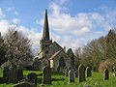
St Mary’s church, Huggate, is currently listed - grade 1. It is a pretty church in an attractive setting, with a fine interior.
The following information about St Mary’s Church, Huggate is taken from Bulmer's History and Directory of East Yorkshire (1892) —
“The church of St. Mary is supposed to have been originally erected about the year 1220, by Ralph Paganel, whose ancestor of the same name came over with the Conqueror, and stood high in the royal favour. It was thoroughly restored in 1864, when a large portion of it was rebuilt. The plan comprises chancel, nave, aisles, south porch, and an embattled and decorated tower with a lofty octagonal spire, containing two bells. The nave is divided from the aisles by arcades of three pointed arches, and a very fine arch of the same style divides the nave and chancel. The east window is a memorial of the late Jas. Christie, Esq., erected at the expense of the tenants in 1884. The ancient octagonal font is still in use.”
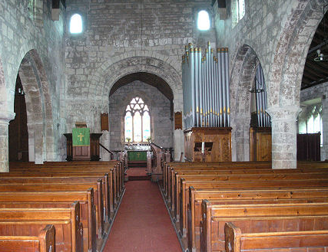
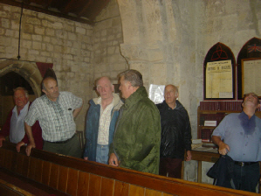

Our final stop was to see the location of the ancient village well in Huggate.
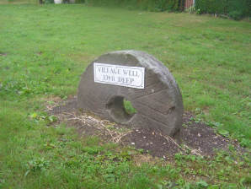
Huggate has the second deepest well in England, reputedly at a depth of 339 feet. It was sunk in 1765. In his memoirs (1873 to 1883), Joseph Smith said of the well:
“It has been disused for some years owing to the great difficulty in raising the water, the bringing up of a bucket of water taking two men from 15 to 20 minutes in winding it to the surface, which was a very tedious operation. Many cisterns have been made of late years, therefore the old well was boarded up. Most visitors to the village were eager for a look into its dark depths, so we generally had to raise a board in order to satisfy their curiosity.”
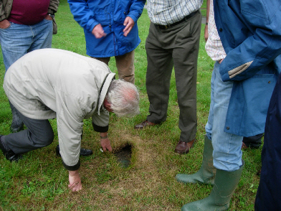
The well cover is now grassed over, but members of the group were eager to see the cover and perhaps see down the well …
… unknowingly almost keeping with tradition!
Unfortunately, due to the weather, the walk around the village had to be postponed —
perhaps an event for the autumn? `

