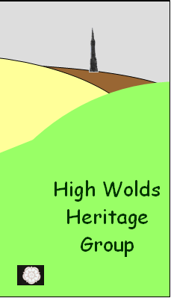
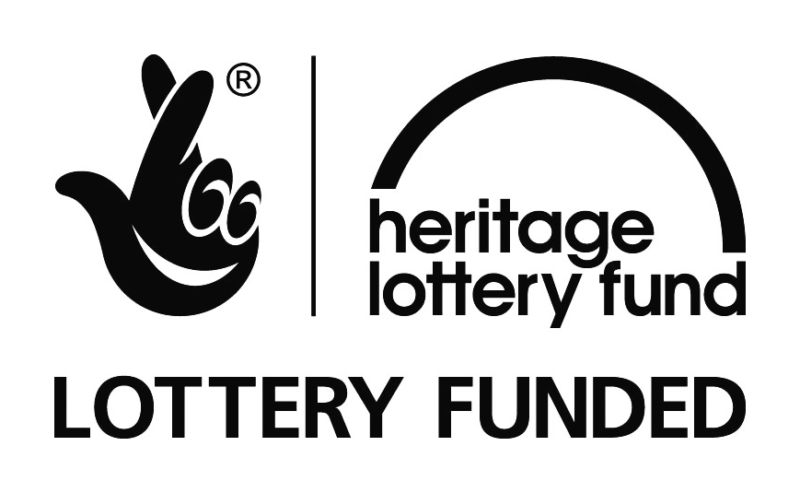
Hind Houses and Memories of North Dalton
by Ray Williams and Peggy Dunn
February 24th 2011

Ray and Peggy gave informative and entertaining presentations to members of the HWHG. Ray started by giving some background about his involvement with recording radio plays for the BBC and the folk music scene. His skill in sound technology and interest in local history led him to work with older residents of North Dalton on an oral history project. He recorded hours of interviews with local men and women which he then edited thematically to produce a CD. He played a short extract from it for the audience and talked a little bit about how amazed he had been by some of the experiences of the old men and women he interviewed. He went on to explain that Peggy is not on the CD because she had so many stories to tell that she had been persuaded to write a book about her experiences instead!
Peggy then went on to talk about her working life helping her mother run several different hind houses in the North Dalton area. The hind house was where the farm labourers were housed and fed. The numbers would vary depending upon the size of the farm but the first one which her mother and father ran had eighteen men ‘living in’ and many more to feed when casual labour was taken on at harvest time. Peggy, who is now eighty-four, started helping her mother when she was eighteen. Neither of them had done work of this nature before so there was a lot of ‘learning on the job’ but it seems that they were both very capable and the men were well looked after. Peggy had to turn her hand to many unexpected tasks including butchering a pig one day when the butcher failed to arrive in time because of the snow.
The audience asked lots of questions and were impressed by the amount of work that Peggy and her mother would get through each day without any of the modern equipment which we enjoy nowadays.

