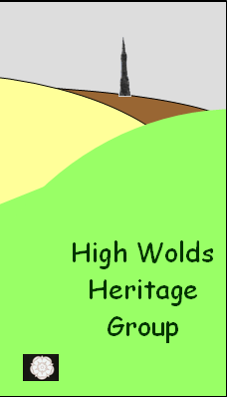
Geology of St Nicholas Church, Wetwang, East Yorkshire.
Introduction
This summary report is for the guided walk held on Saturday 9th April 2011 for the High Wolds Heritage Group for their use and concentrates on the building materials of the Church and village and their relationship with local geology and archaeology. The walk was arranged by the Wetwang History Group.

Local Geology and Landscape
Wetwang village stands on a ridge above the dry valley of Wetwang Slack that form part of the drainage basin of the River Hull and which is in-filled with post glacial water-lain sands and gravels. The local bedrock is Late Cretaceous Chalk that is gently dipping to the south beneath which at depth are a series of limestones, sandstones and clays of Jurassic Age.
The Chalk of the Yorkshire Wolds is harder than that of its southern equivalent largely due to tectonic pressures associated with faults and Alpine mountain building movements that occurred about 30 million years ago. The Chalk is pervious, i.e. has internal joints that allow water to pass through to produce a dry surface landscape with an underground aquifer that emerges at the surface as springs at the junction with the underlying clays along the western and northern scarp edges of the Wolds. In the East the aquifer makes contact with the glacial deposits of Holderness forming another spring line. Only in the deepest of the Wold dry valleys do springs rise and these tend to be seasonal. Wetwang therefore has always had a problem with water relying on local wells and underground cisterns, whilst the village pond is probably a ‘dew pond’ either lined with puddle clay or situated on a patch of residual ‘clay – with – flints’ or on boulder clay from the last Ice Age (erratics from which were seen during the walk). It should be noted that during the last Ice Age the Wolds were ice free with a seasonal tundra landscape. At the end of the last Ice Age melt water ran over the frozen chalk surface to cut valleys and depositing sands and gravels which subsequently became dry as the water table became established as the ground thawed out. The valleys were later filled with rain wash deposits associated with late prehistoric and later farming activities burying earlier archaeological remains.

The Church and its Building Stones
As with all Wold Churches St Nicholas is built of alien stone as the Chalk is of such low status and quality as to be confined to local houses and farm buildings many of which have now been replaced by brick (both handmade and mass produced). Thus to make a Church a lasting monument the medieval (and subsequent builders) had to source the stone from outside the area either directly as primary stone (direct from quarries) or as secondary (robbed) stone. It is now thought that the older churches were built of reused stone from the many Roman farms, villas and temples that once covered the Wolds and only later was it possible to source primary stone from distant quarries using improved transport links such as the railway. Unfortunately it is often difficult without written records to date individual stonework or its source however in this case the Sykes Family were the wealthy benefactors who could employ top architects and source high status stone for rebuilds and additions, unlike some other Wold churches that had to rely on a mixture of reused stone or even hand made bricks (made from local boulder clay) for such work.

Building Stones recorded
As with many older Wold Churches the dominant building stone is Calcareous Grit (probably Birdsall Calcareous Grit) a buff – grey marine sandstone of Late Jurassic age cemented by the calcareous fragments of sponges known as spicules. It can be fossiliferous with worm burrows, bivalves and occasional ammonites and was deposited in a shallow water environment similar to Bridlington Bay today. Primary sources for this stone are Birdsall (medieval and C19), Acklam (C19?) and Filey Brigg (Roman, Medieval and C19). The bulk of the medieval stone for the Church was probably robbed out from nearby Roman sites as indicated by standardised ashlar blocks with evidence of previous use. Unfortunately the rock is easily decalcified by modern air pollution (including car exhausts) especially on the sides facing the prevailing westerly winds and so has to be replaced with other building stones. A large square block in the churchyard is made of calcareous grit and is thought to be Roman in origin but reused as the base for the village cross; likewise the medieval grave cover depicting 2 infants is also likely to be of this rock as well as the medieval font.
The next most common rock are Channel Sandstones that are reddish brown to grey in colour and were formed in sub tropical/warm temperate coastal swamps crossed by meandering rivers from either the Mid/Late Carboniferous or Mid Jurassic depending on the source of the stone (Pennines or North York Moors). As the environments are very similar for both geological periods, examples are very difficult to date by eye. Fossils are rare but sedimentary structures are very common including cross bedding and de-watering structures (sand volcanoes), together with occasional nodules of ironstone. These sandstones were frequently used as ashlar blocks in rebuilds, the construction of buttresses and later additions, such as the Chancel. More recently, single blocks have been used to replace rotten calcareous grit as there are few other alternatives available to builders. They tend to be weather resistant but blocks with softer cross bedding can be eroded. Channel sandstones are also used as flagstones with reused examples in the Lychgate wall, inside the church and as grave stones.
The most exotic rock recorded is the late Jurassic Hildenley Limestone that was laid down in a faulted marine trough in the Howardian Hills and is not known from any other locality. At least 10 ashlar blocks of the shelly variety (type 5) were seen with characteristic fossils such as bivalves and echinoid (sea urchin) spines. This rock has been quarried from Roman times to mid C19 as a highly desirable high status stone with frequent reuse over time (including the dissolution of the monasteries) and is recorded from a large number of Wold churches as far south as the Humber. It is easily recognised by the colonies of bright yellow lichen that grow on it due to the high calcium carbonate content.
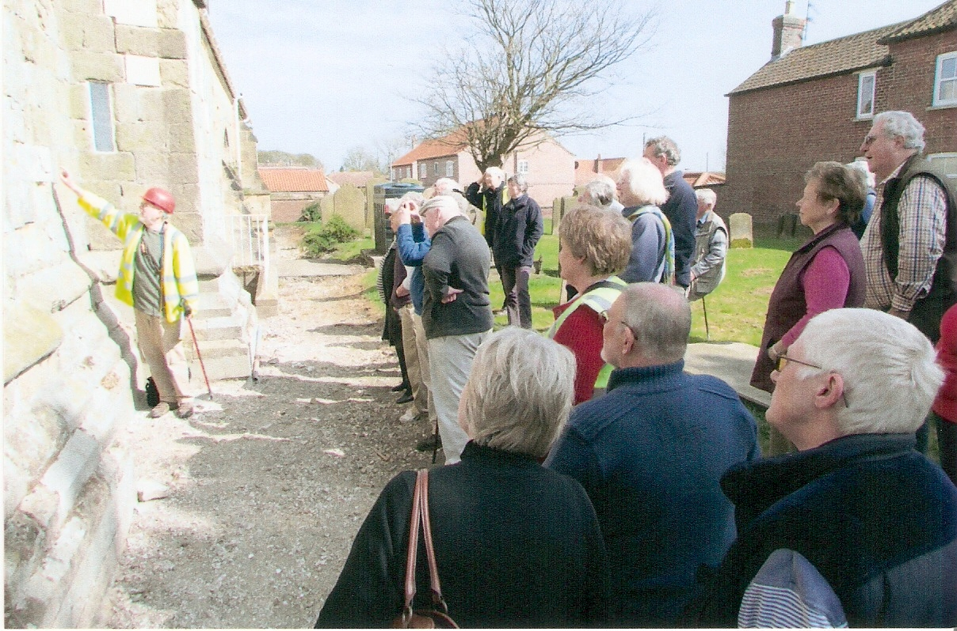
Richard points out fossils and the Hildenley limestone
The local Chalk being softer and lower status than the alien building stones is frequently confined to the interior of churches although it is sometimes difficult to identify due to many centuries of lime wash. It frequently occurs as blocky (rough cut blocks) or rubble (no preparation) on internal walls or as infilling between the exterior and interior walls. Rarely is it found as an external building stone.

Conclusion
“The fascinating history of the development of this church from the C11 to the C20 can be traced in the stonework and fitting …….” (Sykes Church Trail – Southern Route) and this was illustrated by the building stones recorded from the earliest use of secondary stone robbed from Roman sites to the use of high quality stone during the building phases carried out under the patronage of the Sykes Family. The Wolds is a unique area for churches built of alien stone instead of the local Chalk and the longevity of the churches is testimony to the choices made by the builders over the centuries.

Richard Myerscough. BA, Cert.Ed, ADES, Cert.Arch, FMF, MifL
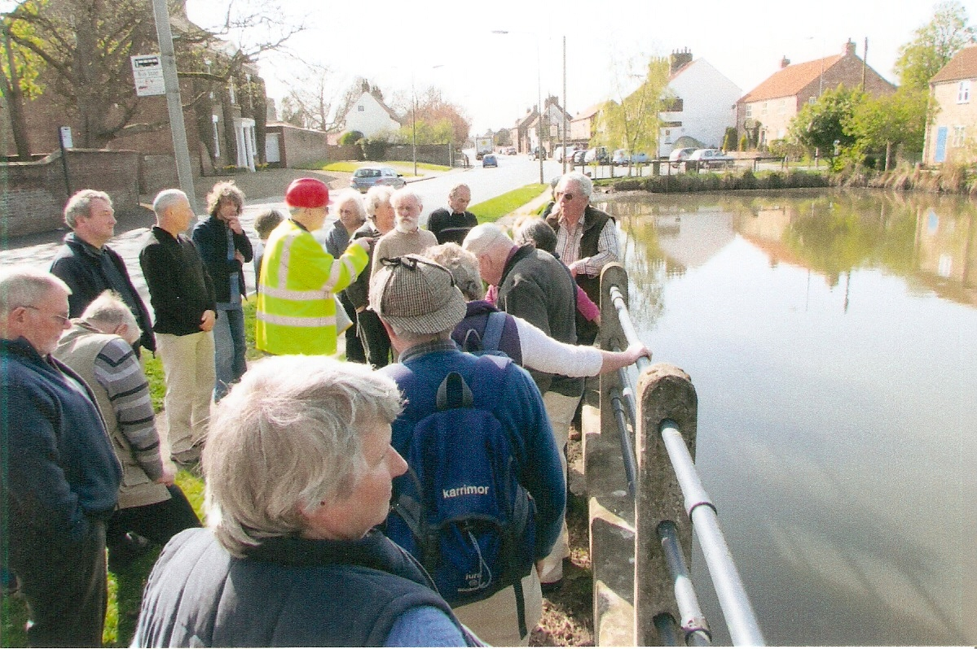
The walk continued to Wetwang pond
University of Hull (Centre for Lifelong Learning)
Bridlington University of 3rd Age (Geology and Church Studies Coordinator)
PLACE (Fellow)

