Graveyard Discoveries
Monday 27th June at Wetwang Village Hall
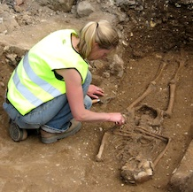
Malin Holst, the osteoarchaeologist who supervised recent excavations in Wetwang and Fridaythorpe churchyards, gave a fascinating presentation about her work. She presented a series of slides illustrating the different types of research she has been involved with and showed photographs, charts and maps of the excavations at Wetwang.
During the excavations in Wetwang churchyard a black cup was found in an early 18th century grave. Surprisingly it is entirely undamaged. In its day, this cup would have been cheap locally made pottery for daily use. This ordinariness meant that very little of its type has survived, which in turn means that this cup is very rare – but not valuable! It is now in safe care at Wetwang.
Owing to financial constraints she was unable to conduct certain tests on the bones they unearthed but even without those tests the trained eye can tell a lot about the individuals concerned. Some bones showed evidence of illness and trauma from injuries but perhaps the most unexpected discovery is that the bones showed that people in Fridaythorpe were taller than people in Wetwang!

The event was well supported with an audience of around sixty.
You can read more about Malin’s work on
http://www.york.ac.uk/archaeology/staff/research-staff/malin-holst/

